Shirley (Chauvin) Waguespack
November 29, 1942 – August 26, 2007
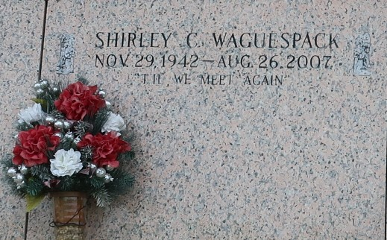

Shirley Chauvin Waguespack, age 64. Born November 29, 1942. Went to live with her heavenly Father on Sunday, August 26, 2007 surrounded by family and friends.
Beloved wife of Lynn Waguespack of 44 years. Daughter of Dorothy "Dot" Chauvin Burks and the late Elmore J. Chauvin, Sr. Mother of Connie, Carol, Libby and Linette. Grandmother of Kaci, Brittany, Jeremy, Jessica, Jade, Dylan, Brandon, & Taylor. Sister of Barbara Dugas, Elmore J. Chauvin, Jr. and Susan Lambremont.
Visitation Tuesday, August 28, 2007; 9-12:30 at Alexander Funeral Home in Norco. Services at 1pm at St. Charles United Methodist Church in Destrehan. Interment at St. John Memorial Gardens, LaPlace, LA.
Times-Picayune, New Orleans, Louisiana
Tuesday, August 28, 2007
Contributed by Jane Edson

