Hugh Hanson Waldrup
July 13, 1914 – March 18, 1985
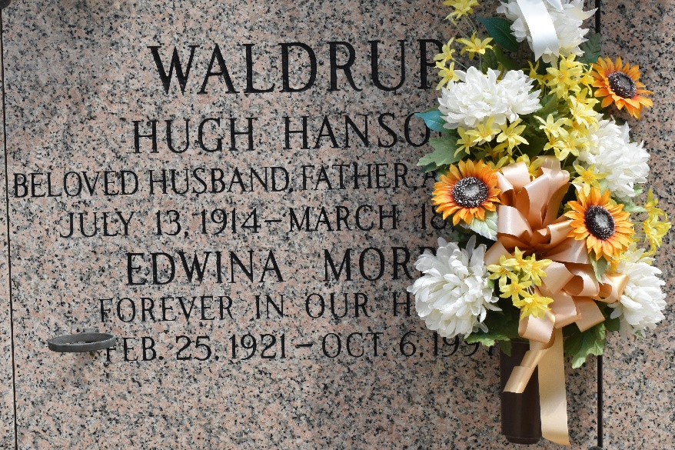

Hugh (Hank) Waldrup on Monday, March 13, 1985 at 12:47 p.m. Beloved husband of Edwina Morris Waldrup; father of Robert, Richard and Thomas Waldrup, Sharon Black and Becky Waldrup; also the late Arion Waldrup; brother of Ruby Wiliford, Dorothy Parsons, Lucy Brocato and Sue Deodoti; also survived by 11 grandchildren and 3 great-grandchildren; age 70 years, a native of Alabama and a resident of Laplace for the past 22 years.
Relatives and friends of the family, also Members of the Progressive Masonic Lodge No. 262 F&AM and Members of the Plumbers and Steamfitters Local 60 New Orleans are invited to attend the funeral services from Millet Funeral Home, Laplace on Wednesday, March 20, 1985 followed by religious services at Lasseigne's Memorial Church at 10 a.m. Interment in St. John Memorial Cemetery, Laplace. Friends may call from 5:30 until 8 p.m. on Tuesday, March 19, 1985 and from 8 a.m. until services on Wednesday.
Times-Picayune, New Orleans, Louisiana
Tuesday, March 19, 1985

