Dave Walker
June 17, 1977 – May 19, 2022
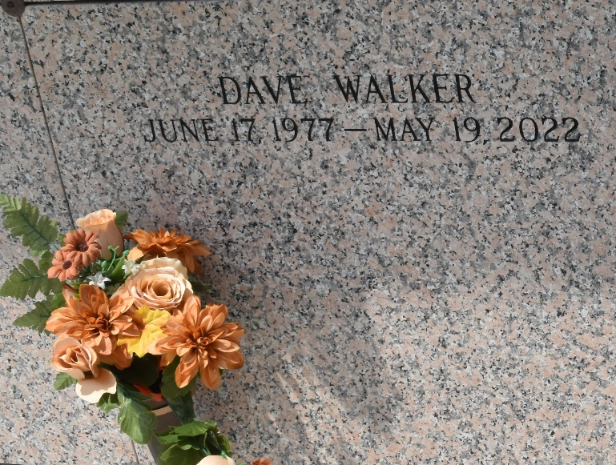

Dave Walker was born to Theresa and the late William Walker Sr. on June 17, 1977. He attended school in Jefferson Parish School System. He was baptized in 2021 at St. Michaels Baptist Church. He tragically passed away on Thursday May 19, 2022.
Dave was affectionately known to family and friends as "David"," Shorty Doo Wop" & "Sandman". Some of his favorite things to do were shopping, eating, partying and cracking jokes. He was the proud dad of 2 daughters: Tatyana & Alicia Walker, and grandfather of one grandson, Jahkaire. He loved his family dearly. At the time of his departure, he worked at A3M in Laplace, La.
He was preceded in death by his father, William Walker, Sr.; siblings, Brandon, Devora and Stephanie Walker, and Antonio Woodard; uncles, Leroy and Ronnie Taylor; aunt, Deen Taylor; and his children's mother, Elisha Herring.
He is survived by his beloved mother, Theresa Walker; siblings: Sylvester (Dawn)James, William Jr, Kim (Eric), Alicia, Cathy (Eric), Pamela Walker, Patricia and Willie James, and Sharome Davis; nieces and nephews: Jamal, Jamell, Clisha, Clishonda, Nevaeh, James Jr., Eric Jr., Victoria, Aryah, Journey, and Kairo. He is also survived by many aunts, uncles, cousins, friends, and his A3M family. He was loved by family and friends and will be missed by all who knew him.
A celebration of life honoring Dave will be held on Saturday, May 28, 2022 at First Assembly of God Church, 3001 US-51, Laplace, LA 70068. Visitation will begin at 9am until services begin at 11am. Interment to follow at St. John Memorial Gardens, 2205 W Airline Hwy., Laplace, LA 70068.

Treasures of Life Funeral Services, Gramercy, Louisiana

