Freida (Rome) Walker Newcomb

March 20, 1922 – February 13, 2004

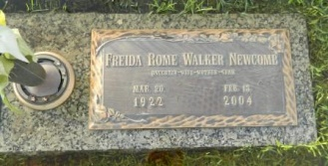

Photo by Margie Pearce

LAPLACE - Freida Rome Walker Newcomb, 81, a native of Vacherie and resident of LaPlace for 78 years, died Feb. 13. She was the wife by first marriage of the late John P. Walker Sr. and by second marriage of the late Jessie Newcomb, and mother of John P. and Karl Walker, and Debora Frita. She is also survived by five grandchildren and one great-grandchild. She is preceded in death by one great-grandchild.  
  
She was also the daughter of the late Jean and Elucia Mury Rome, and sister of Lisa Crabtree, Ann Seizer, Thomas Ignece, Jean Jr. and Russell Rome, and the late Amy Ocmond, Emelia, Eddie, Clincy, Sterling and Edward Rome  
  
Services were Feb. 15 at First Baptist Church, LaPlace, with interment at St. John Memorial Gardens, LaPlace.

L'Observateur (La Place, LA) - Wednesday, February 18, 2004