Ricardo Sean Wallace
January 6, 1989 – February 11, 2018
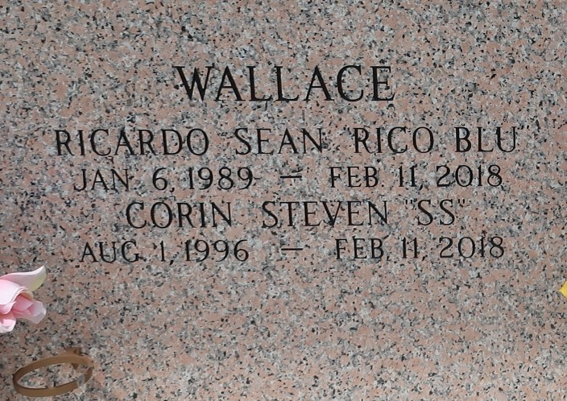

On Sunday, February 11, 2018, Ricardo Sean Wallace heeded the Master's call. Ricardo, 29 years old, a native of LaPlace, LA. Being a very quiet humble young man of very little words but a heart made of entirely selfless actions, he leaves to cherish his memories, his loving parents Barry Wallace and Dana Bardell Wallace, son Roman "Rocket" Wallace. Paternal grandmother, Daphne McClean and Maternal grandfather, Kenneth Bardell. Proud nephew of Margo Davis (Wendolyn); Kerri Santiago (Jose') of Sunset, LA; Kiandre Bardell, and Kennette Bardell. Devoted cousin of: Jade, Paige and Jordan Davis; Shelby, Travis, Miles and Jaren Santiago; Kash and Kash'Mir Foley, Kassidy Watkins and Kennedy Gerard. Devoted friend of: Jocelyn Hayes, Andre Williams, Chris McLaurin, Coi Baloney, Cardell Wallace, Carlin Farlough, Herman Farlough Jr., Nolan Noble, Jaris Scott, and Preston Poche III. Also survived by a host of aunts, uncles, cousins other relatives and friends.
Preceded in death by his maternal grandmother: Corinne Bardell and paternal grandfather, Steven McClean. Joined in eternal rest with his best friend and brother Corin Wallace.
Relatives and friends of the family, also pastors, officers and members of New Wine Christian Fellowship of LaPlace, LA, and all neighboring churches are invited to attend the Celebration of Life service on Saturday February 24, 2018, at 11:00am at New Wine Christian Fellowship 1929 W. Airline Hwy. LaPlace, LA. Rev. Neil Bernard ,is the Pastor. Pastor Marc Allen Nelson Sr. is officiating. Interment in St. John Memorial Garden of LaPlace, LA. Visitation will be Friday February 23, 2018 from 3pm to 5pm at Bardell's Mortuary 3856 Hwy. 44 Mount Airy, LA, and on Saturday February 24, 2018 from 9:00am until service time, at New Wine Christian Fellowship.
The New Orleans Advocate, Louisiana
Feb. 21 to Feb. 24, 2018

