Susan M. (Gendron) Walls
1958 – March 8, 2020
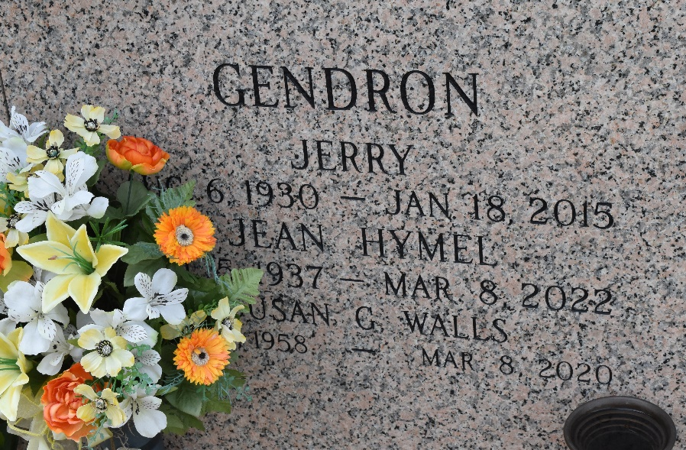

Susan M. Gendron Walls was called home on March 8, 2020. She was a proud native and long time resident of LaPlace, LA.

She was the loving mother of Brittany Walls and Brooke Walls (Israel). Beloved grandmother of Lexie, Trey, Mackenzie, Isabella, Anastasia, Saige and Mariah. Daughter of Jean Gendron and the late Jerry Gendron and eldest sister of 5.

Relatives and friends are invited to attend the visitation at Millet-Guidry Funeral Home, 2806 W. Airline Hwy, LaPlace on Saturday, March 14, 2020 from 10:00 a.m. to 12:00 p.m. followed by a Memorial Service at 12:00 p.m. To share memories or condolences, please visit www.milletguidry.com.
The Times-Picayune, New Orleans, Louisiana
March 12-14, 2020

