David Craig Walter

August 24, 1953 – August 23, 2009

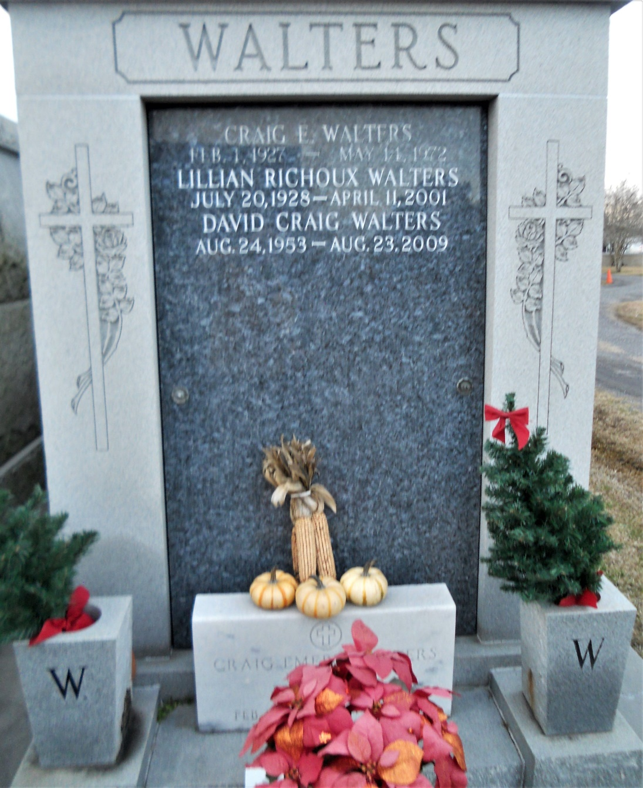

Photo by Team T Lo

David Craig Walter, a retired pharmacist with LSU Earl K. Long Medical Center, died Sunday, Aug. 23, 2009. He was 55, a resident of Prairieville and native of LaPlace. Interment in St. John Memorial Cemetery, LaPlace.

Gonzales Weekly Citizen (Ascension, LA) - Friday, August 28, 2009

Contributed by Jane Edson