Lillian (Richoux) Walters

July 20, 1928 – April 11, 2001

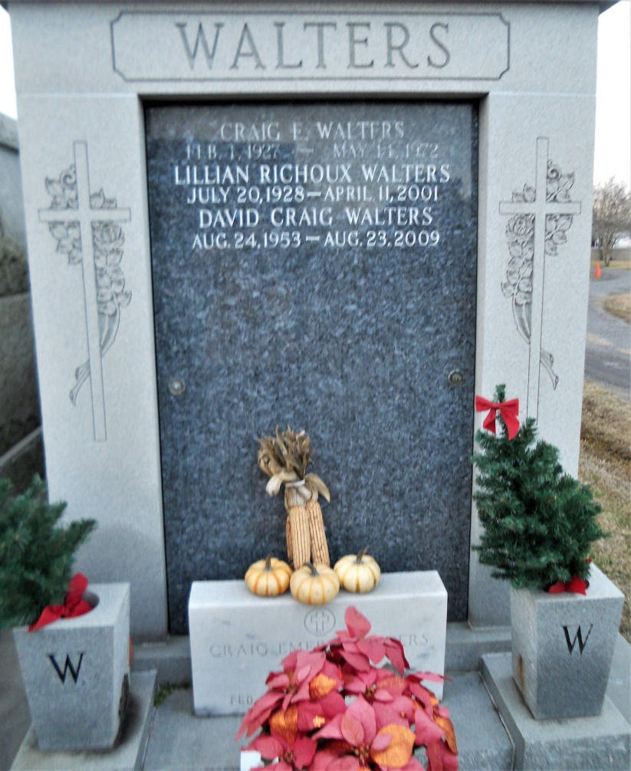

Photo by Team T Lo

Lillian Richoux Walters, 72, a native of Montz and resident of LaPlace for 45 years, died April 11. She was the wife of the late Craig Walters and mother of Cynthia Ziegeler, Mary Simon and David Walters. She was also the daughter of the late Nicholas and Lillian Richoux and sister of the late Amy Duhe, Verlie Walker, Mable Millet and John, Lester, Lynnwood, Ridgely and Robert Richoux. She is also survived by seven grandchildren and one great-grandchild. Services are today at 11 a.m. at St. Joan of Arc Catholic Church, LaPlace, with interment at St. John Memorial Gardens, LaPlace. Visitation starts at 8 a.m.

L'Observateur, LaPlace, LA; April 14, 2001