Marion Elise (Watkins) Ward
October 30, 1944 – October 4, 2021

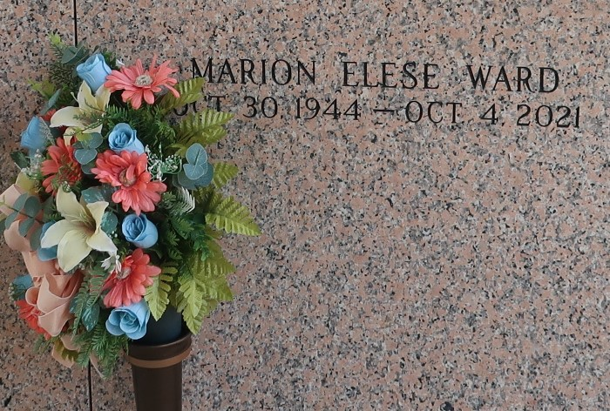
Marion Elise Watkins Ward was born on October 30, 1944 to the late James and Lorenza Watkins in Laplace, Louisiana. Marion was predeceased by her parents James Cornealius Watkins and Lorenza Gabriel Watkins. She was the sister of the late Nelson, Clarence, Sterling, Azelia Fobb, Hilda Batiste, Audrey King and Barbara Julien.
She is survived by her siblings Nellie Farlough, Betty Ann Sonny, Joyce Taylor, and Cornelius. She was one of twelve siblings. She was married to the late Paul Schnyder Sr. and in that union, they were blessed with three children: Darlene Dean (Patrick) of Los Angeles, CA. Paula Henderson (Wendell “Brick”) of Laplace and Paul Schnyder Jr. (Ingrid) of Slidell, LA. She later married the late Reverend Raymond Ward and moved to Los Angeles.
Marion was a steadfast grandmother to Demetrius Respress, Kearan Dean, Collin Dean, Morgan Dean, Chase Henderson, Cole Henderson, and Ke’Erra Williams Davis. A loving great grandmother to Layah Respress, Neriah Watley, Wyatt Williams Watley, Angel Denet and Kamari Dean. Her memory lives on forever and she leaves to cherish precious memories with her children, grandchildren, great grand-children, siblings Nellie Farlough, Betty Ann Sonny, Joyce Taylor, and Cornelius Watkins. Devoted god-children: Durwin Farlough and Leo Schnyder. She will be missed by a host of nephews, nieces, cousins, friends, and family.
She was blessed with many talents holding various occupations including administrative work, Dietary staff position and her passion job as a Caretaker. Marion received her primary education from St. John The Baptist Parish school system. She graduated in May of 1963 from Fifth Ward High School in Reserve, LA. At a young age, she gave her life to Christ and was baptized by the late Reverend Samuel Jones of Providence Baptist Church in Laplace, LA. Following her retirement, Marion devoted her life to her passion of Caretaking and sitting with the elderly. She was the one known for always smiling and making you laugh.
Relatives and friends of the family, Pastor, Officers, and members of St. Mark Baptist Church are invited to attend the funeral service on Tuesday, October 12, 2021 at 10:00AM at St. Mark Baptist Church 132 Marquez Street, Mt Airy, LA. There will be a visitation at the Patrick H. Sanders Funeral Home-605 Main Street, LaPlace, La on Monday October 11, 2021 at 3:00PM for the family and 4:00pm until 7:00PM for the public. In accordance with the CDC guideline for COVID-19 guidelines all in attendance must wear a mask and practice social distancing. There is also a visitation at the above-named church at 9:00AM until time of service on Tuesday, October 12, 2021. Interment at St. John Memorial Gardens, LaPlace, LA. Final Arrangements entrusted to Patrick H. Sanders Funeral Home & Funeral Directors, Inc., 605 Main Street, LaPlace, LA. For Information 985-359-1919.
The Patrick H. Sanders Funeral Home, LaPlace, Louisiana

