Percy Huey Warren Jr.
July 26, 1960 – October 29, 2020
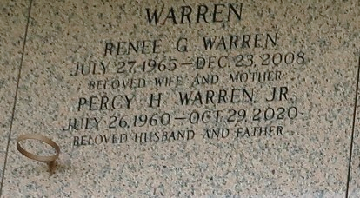

Percy Huey Warren, Jr., age 60, passed away on Thursday, October 29, 2020. Son of the late Rev. Percy Huey Warren Sr. and Pearl Rodney Warren, husband of Annette Ratliff and the late Renee Gant Warren, loving father of Angelique Warren (Casey Washington), Ayunta Warren (Craig Moll), Latasha Warren (Renardo Gerard), Jeremiah Warren (Jada), and Percy H. Warren III (Joy), brother of Deborah Godon, Ivy Bethencourt, Sharon Boudoin, Carlis Griffin, Deseree Nelson, and Rev. Bryant Warren. He is survived by 3 sons-in-law, 2 daughters-in-law, 27 grandchildren, a host of other relatives and friends.

Family and friends are invited to join in the Celebration service on Friday, November 6, 2020 at Greater Morning Star Baptist Church, 1003 Balsam Street, LaPlace, LA 70068 at 10:00 a.m. Rev. Bryant Warren officiating. Viewing at 8:00 a.m until service time. Interment in St. John Memorial Garden Cemetery, LaPlace, LA 70068. Visitation on Thursday, November 5, 2020 at Bardell's Mortuary, 3856 LA-44, Mt. Airy, LA 70076 from 3 p.m. until 5 p.m. Services entrusted to Bardell's Mortuary. Information: (985) 535-6837.

The Times-Picayune, New Orleans, Louisiana
November 4-6, 2020

