Renee (Gant) Warren
July 27, 1965 – December 23, 2008
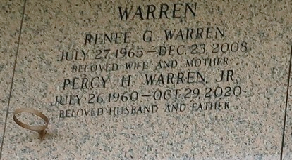

Renee' Warren, age 43, departed this life on Tuesday, December 23, 2008 in Laplace, La. Wife of Percy Warren, Jr. Mother of Ayunta Moll, Latasha Gerard, Jeremiah, Angelique and Percy Warren, III. Sister of Germaine Shears, Michael and Jumel Gant, Jr. Also survived by daughters and sons in law, mother in law, sisters and brother in laws and a host of nieces, nephews, cousins, other relatives and friends. A native of McComb, Mississippi and a resident of Reserve.

Service will be held at the Greater Morning Star B.C. All neighboring churches are invited to attend the funeral service at the above named church, 1003 Balsam St., Laplace, La., at 11:00a.m. Rev. Bryan Warren, Sr., Pastor Officiating. Interment in St. John Memorial Cemetery Laplace, La. Viewing at the church at 10:00a.m. until service time. Service Entrusted to Hobson Brown Funeral Home Garyville, La., 985-535-2516.

The Times-Picayune, New Orleans, Louisiana
Dec. 29, 2008

