Verna Mae (Williams) Warren
March 13, 1948 – June 21, 2021
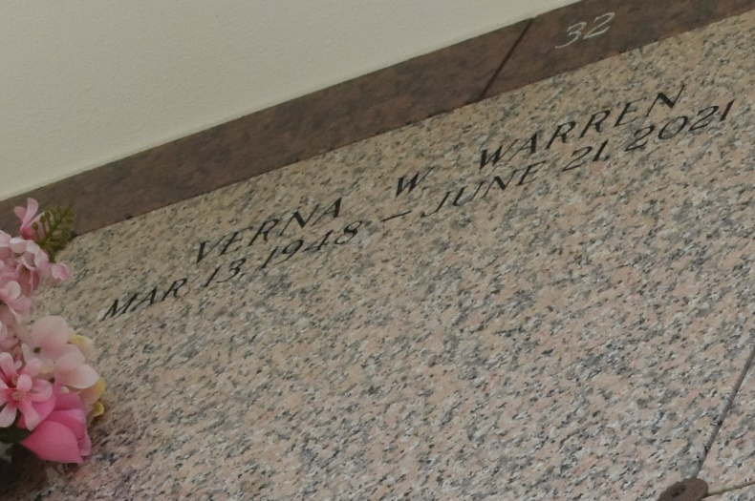

On March 13, 1948, Verna affectionately known as "Marie Jean (My-Ree John) was born to the late Rev. Medrick Williams, Sr. and the late Rosalie B. Williams. She was the second child of fifteen children. She was raised in a Christian home and accepted Christ at an early age being baptized by the late Bishop Joseph Warren, Sr. of the Greater Morning Star Baptist Church of Laplace, La. Verna's early education began at Our Lady of Grace Catholic Church and furthered within the St. John the Baptist Parish School system. On April 1, 1972, Verna was united in Holy Matrimony to Benjamin Warren. To this union, three children were born: Cory Dale Warren, the late Jayson Amez Warren, and Nedra W. Richard.
Verna was a caretaker all of her life and really enjoyed her solitude with a determined will focusing on her spirituality. The happiest moments in her life were attending church and being around children especially her nieces and nephews, giving them all the same scripture and encouragement. Verna was also a great seamstress, often providing her skills and talent for the church drill team and the choir clothing as well as her own family. Loving her husband dearly along with family gatherings and cooking for the holidays were among the many other family moments she embraced.
Verna began her walk of faith by "making a joyful noise not the Lord" starting from an adolescent in the Junior Choir to adulthood in the Senior Choir with her desire being singing and playing the organ then later becoming the organist and choir director as she was steadfast in singing praises unto the Lord. She continued her walk of faith under the leadership of Rev. Mollaire at the Good Hope Baptist Church for many years. Verna later became a member of Mount Nebo Baptist Church under the leadership of Rev. Augustus Brown serving as a Sunday school and vacation bible school teacher as well as choir director and soloist.
On June 21, 2021, God strolled through His earthly garden and picked a bouquet of flowers. Among the bouquet was our rose, Verna Mae, whom he called home. She fought a good fight, finished the race, and kept the faith unto the end (2 Tim 4:7).
Verna leaves in continuation of life, her loving husband, Benjamin Warren, children-Corey Dale Warren and Nedra W. Richard; son in law-Darnell Richard; grandchild-Neiah Darnell Richard; brothers, Deloyd Williams, Sr. (Sharon), Lionell Williams (Cheryl), Medrick Williams, Jr. (Gwen); brother-in-law, Edgar Zeno, Sr.; sisters-Marva Joseph (Melvin, Jr.), Yvonne Smith (Juansley), Norma Dorris, Marilyn Warren (Samuel, Joyce Bush(Mike), Marlene Watkins (Irvin), Sheryl Pierre (Alexis); sisters-in-law, Cloria Clark, Selena Paul, Helen Warren, and Mary Boatner; godchildren-Edgar Zeno, III and Medrick Williams, Sr.
She was preceded in death by her parents, Rev. Medrick, Sr. and Rosalie Williams; son, Jayson Arnez Warren; sisters, Aline Zeno, Bernadette Batiste, Rose Marie Francois; brother, Gerald Williams; nephew, Brandon Williams.
The community of Reserve and surrounding areas of the River Parishes as well as family and friends are invited to attend the Celebration of Life Service on Monday, June 28, 2021 for 12:00 noon at Treasures of Life Center for Life Funeral Services, 315 E. Airline Hwy, Gramercy, LA 70052. A public visitation will begin for 11:00 am. FINAL VIEWING PRIOR TO SERVICE. Entombment to follow at St. John Memorial Gardens, 2205 W. Airline Hwy, Laplace, La 70068.

Treasures of Life Center for Funeral, Gramercy, Louisiana

