Curtis Jeffery Baker Jacobs
May 30, 1985 – May 21, 2003

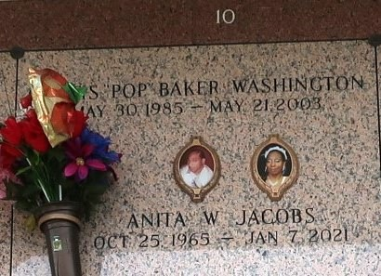

Curtis 'Pop' Jeffery Baker Washington, A Senior At East St. John High, Departed This Life On Wednesday, May 21, 2003 At His Residence In Reserve, La. Son Of Anita Baker Washington And Carl Primas And Stepfather, Harold Washington, Sr. Brother Of Carlos B. Washington And Kendra B. Washington. Stepbrother Of Harold Washington, Jr., Jeremiah Spain And Lashawn Spain. Grandson Of Almeta Baker, The Late Alexander Baker, Sr., Rose Lee Robinson And J.D. Primas. Survived By A Host Of Great-Grandparents, Uncles, Aunts, Nieces, Nephews, Cousins, East St. John Graduating Class Of 2203, Relatives And Friends. A Native And Resident Of Reserve, La. Age 17 Years.
Relatives And Friends Of The Family; Pastors, Officers And Members Of Riverlands Christian Center Church And All Neighboring Churches; Faculty And Student Body Of East St. John High School Class Of 2003 Are Invited To Attend The Funeral Services From The Above Named Church, 123 Redemption Way Dr., Reserve, La., On Saturday, May 24, 2003 At 11:00 A.M. Rev. Steven Perrilloux, Pastor - Officiating. Interment In St. John Memorial Gardens, Laplace, La. Visitation Will Begin At 10:00 A.M. At The Church Until Funeral Time. Services Entrusted To Hobson Brown Funeral Home.
Times Picayune, New Orleans, Louisiana; May 23, 2003

