Denese (Johnson) Washington
1956 – October 2, 2022
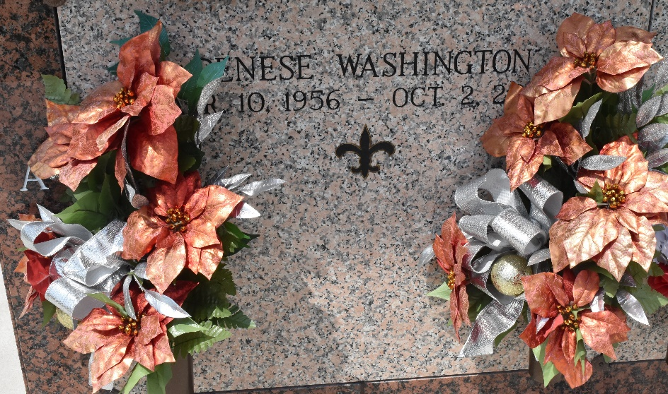

Denese Johnson Washington, at the age of 66, departed this earthly life and entered eternal rest on Sunday, October 2, 2022, at Thibodaux Regional Medical Center in Thibodaux, LA. Daughter of the late Rev. Dennis Johnson Jr., and the late Enola Seals Johnson.
Denese leaves to cherish her memories: her loving daughter, Kyniesha W. Goudia and bonus daughter, Amanda Green; sons-in-law, Glenn Goudia and Micheal Green; grandchildren, Keiron, Kholsten, and Kasyn Goudia, Airelle and Ashondra Toney, and Azia Green; sisters, Hattie LaDay, Ronald (Carol) Johnson, Dennis (Linda) Johnson, Faye (Jerry) Webster, and Herman (Nicole) Stafford; and a host of nieces, nephews, great-nieces, great-nephews, other relatives, and friends.
She is preceded in death by her parents: Rev. Dennis Johnson Jr. and Enola Seals Johnson; and brother, Donald Johnson.
Pastors, officers, and members of First Community Antioch Baptist Church and all neighboring churches, relatives and friends of the family, and employees of St. John the Baptist Parish School System are invited to attend the homegoing celebration on Saturday, October 15, 2022, at 11 am at First Community Antioch Baptist Church, 10860 Hwy 3125, Lutcher, LA 70071. Dr. Steven D. Beckham officiating. Viewing will be from 9 am until service time. Interment: St. John Memorial Cemetery, LaPlace, LA. Services entrusted to Bardell's Mortuary, Mt. Airy, LA. Information: (985) 535-6837.

The Times-Picayune, New Orleans, Louisiana
Oct. 14, 2022

