James O. Watson
August 9, 1940 - August 7, 2020

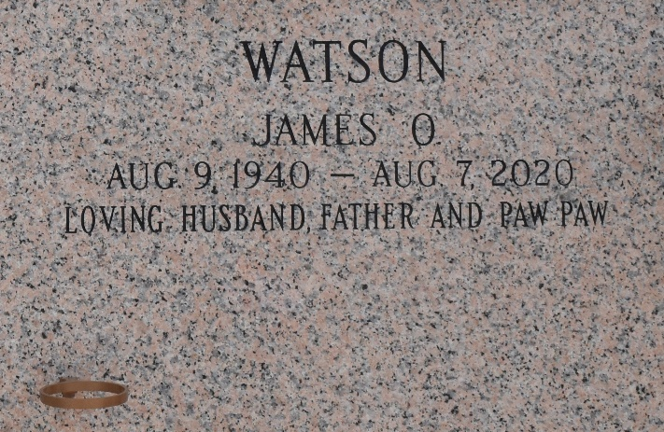

James O. Watson passed away surrounded by his loving family on Friday, August 7, 2020. He was 79, born in Midland, GA and was a resident of Saint Amant, LA. Beloved husband of Peggy Tassara Watson. Loving father of Donna Brignac (David), Michael Watson (Ann), Sandra Tamplain (Robert) and James Watson. Grandfather of Ryan, Tim, Ben, James, Michael, Brittany, Amanda, Tabitha, Robert and Devon. Son of the late Verna Carughi Watson and Willie Watson. Brother of Wayne Watson, Jerry Watson, Edwin Watson and the late Donnie Watson and Cheryl Bourgeois. Also survived by 21great-grandchildren and many nieces and nephews.

Relatives and friends are invited to attend the visitation at LifeHouse Church, 3556 W. Airline Hwy., Reserve on Monday, August 10, 2020 from 9:00 a.m. until 11:00 a.m. followed by Funeral Service at 11:00 a.m. Interment in St. John Memorial Gardens Cemetery.
Millet-Guidry Funeral Home, LaPlace, Louisiana
August 9, 2020

