Mell Webb Sr.
September 10, 1942 – November 15, 2008

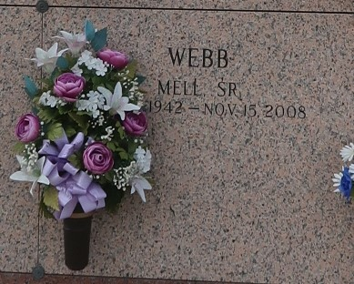
Mell Webb, Sr. age 66, a native of Lettsworth, LA and a resident of LaPlace, LA passed away at Ochsner Hospital on Saturday, November 15, 2008. Beloved husband of Farlene Anderson Webb. Father of Mell Webb, Jr. and Frederick Parker. Son of the late Emit and Mary Dent Webb. Brother of Thomas Webb, Joseph Webb and Annie Tolliver of New Orleans, LA, Henry Webb of Lettsworth, LA, Delia Courtney of Simmes-port, LA and Mack Webb of LaPlace, LA, and four grandchildren, Devin, Pares, Paige and Payton.

Relatives and friends of the family, also members of St. John B.C., First Emmanuel B.C. and St. Peter Claver Catholic Church, Furgo Drilling Co., Eustis Engineering Co. St. John Parish School Board, ITT Technical College, Cox Communication, St. Charles Catholic High School, United Bank & Trust Company and Sunshine Page Company are invited to attend the Funeral Service at 11:00 A.M. on Saturday, November 22, 2008 at New Wine Christian Fellowship Church, 1929 W. Airline Hwy., LaPlace, LA 70069. Visitation will be 9:00 A.M. until 11:00 A.M. Interment St. John Memorial Gardens. Services entrusted to Baloney Funeral Home of Garyville, LA 399 Earl Baloney Dr. 985-535-2540

The Times-Picayune, New Orleans, Louisiana
Nov. 21, 2008

