Ethel (Millet) Weber
December 23, 1919 – December 30, 2018

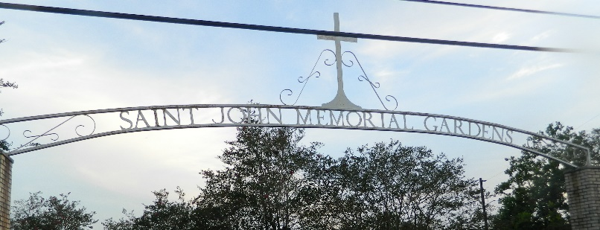

Ethel M. Weber passed away at her home in Norco, LA on December 30, 2018 at the age of 99. She is survived by her son, Robert J. Weber, Sr. (Fiancé Patricia Vicknair), grandchildren, Robert J. Weber, Jr., Aimee W. Mulkey (Shane), great-grandchildren, Alyssa Mulkey and Ainsley Mulkey. She is also survived by her daughter-in-law, Deborah Weber and her extended family, Bonnie and Kevin Kern, Natalie Kern, Katie Vidrine (Rene), and baby Bennett Vidrine.
She is preceded in death by her husband, Samuel Weber, parents, Levy and Veleda Millet, and her siblings. Ethel enjoyed cooking, talking to everyone, and any and all adventures. She will be greatly missed by all who were blessed to know her.
The family wishes to thank her caregivers, Mary Breaux and Karen Sterling for their compassion during this time.
Relatives and friends are invited to attend a visitation at Sacred Heart Catholic Church, 401 Spruce St. Norco, LA, on Wednesday, January 2, 2019 beginning at 9 AM with Mass to follow at 10 AM. Burial to follow at St. John Memorial Gardens in LaPlace, LA.

The New Orleans Advocate, Louisiana
Dec. 31, 2018 to Jan. 2, 2019

