Myrtle (Millet) Weber
September 19, 1920 – April 8, 2020

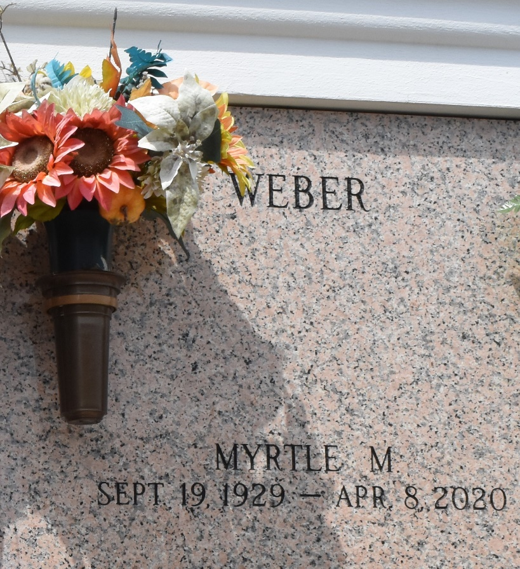

Myrtle Millet Weber, beloved wife, mother, grandmother and great-grandmother, entered the Heavenly gates on Wednesday April 8th at the age of 90.
She was preceded in death by her father and mother, Walter Sr. and Nellie Cooper Millet, her 6 siblings, son-in-law, Mike Hymel, and granddaughter, April Hymel. She is survived by her husband of 76 years, Joseph C. (Prof) Weber Sr., her 6 children and their spouses: Myrtle Landeche (Russel), Rose Mary (Rosie) Monica (Joey Sr.), Patricia (Patsy) Hymel, Joseph C. (JC) Weber Jr. (Bridget), JoAnne Weber, James (Jimmy) Weber (Paula), as well as 13 grandchildren and 18 great-grandchildren.
Myrtle was a life-long parishioner of St. Joan of Arc Church (LaPlace) and a member of the Catholic Daughters. Many will remember her from working in the cafeteria at St. Charles Catholic High School in the 80's and at the St. Vincent de Paul Thrift Shop. She was a sweet, kind and loving lady who touched many lives. She had a strong faith in Jesus and His Mother, Mary. She will be remembered as a loving wife, mother, grandmother, great-grandmother, sister and friend to many. Her beautiful smile and kind heart will be missed by all.
The family would like to sincerely express their gratitude to Marie, Crystal and Lillie for their love and care in her time of need.
As a result of present circumstances the funeral and committal services are private, but our community of friends are important to us. Please consider sharing your thoughts, favorite memory or condolences at www.milletguidry.com.

The Times-Picayune, New Orleans, Louisiana
Apr. 9 to Apr. 11, 2020

