Allen Paul Wempren Sr.
November 14, 1939 – July 17, 2015

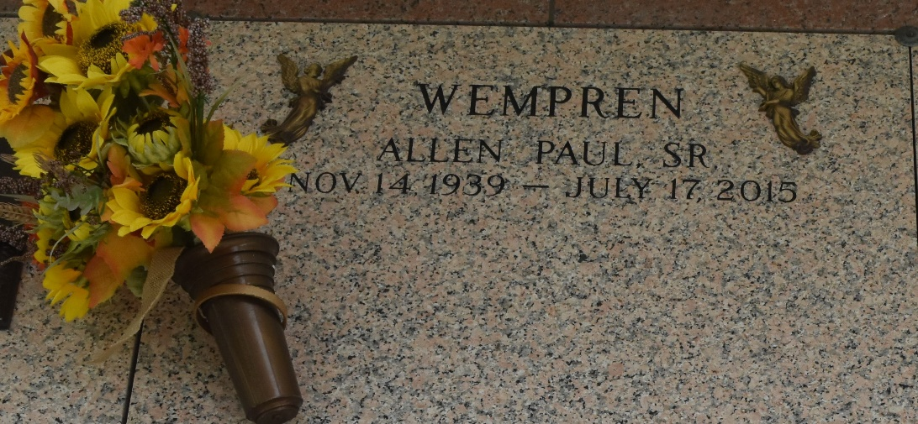

Allen P. Wempren passed away Friday, July 17, 2015 at his home surrounded by his loving family. Allen was a native of LaPlace, LA where he spent 52 years of marriage with Darlene Wiltz Wempren.
He is survived by his children Allen Wempren Jr., Sherry Hubbard(Bill) and Dena Wempren. Grandfather to seven grandchildren; Kailey, Holly, Cody, Brandon, Cory, Kerry and Casey and his one great-granddaughter Brynlee. He is also survived by his siblings Leon Wempren Jr. and Lorraine Roussel.
Allen was a true outdoorsman who has a passion for fishing and hunting. He will be greatly missed by all who knew him.
Relatives and friends are invited to attend the Mass of Christian Burial on Tuesday, July 21, 2015 at St. Joan of Arc Catholic Church in LaPlace, LA at 1PM. Visitation will be held from 10AM till the time of Mass. Interment will follow at St. John Memorial Cemetery in LaPlace, La. In lieu of flowers donations can be made to the Cancer Society. Condolences may be expressed at www.hcalexanderfuneralhome.com
Times Picayune, New Orleans, Louisiana
July 17-19, 2015

