Huey P. Weston
March 22, 1931 – February 14, 2018

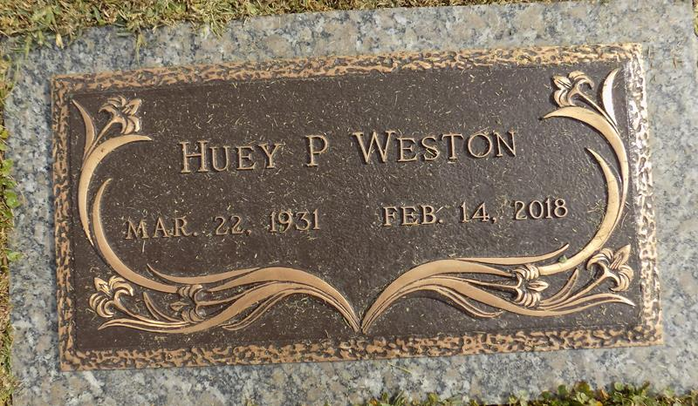

Huey Weston departed this life on Wednesday February 14, 2018, Son of the late Stanley & Aldonia Weston, father of Gloria W. Tassin and Claudia W. (Joseph) Farlough, Brother of Lionel Weston, he is also survived by 3 Grandchildren, 6 greatgrandchildren, a host of other relatives and friends.

Relatives and friends of the family are invited to attend the service on Tuesday February 20, 2018 at 10:00a.m. From True Light B.C. 258 E. Little Hope St., Garyville, La. Rev. Sam Jones, officiating. Rev. Wesley Anderson Sr. Visitation at the church on Tuesday from 8:00am until service time. Interment in St. John Memorial Cemetery. Laplace, La. Service entrusted to HOBSON BROWN FUNERAL HOME, 134 DAISY ST. GARYVILLE, LA, (985) 535-2516.
New Orleans Advocate, The (LA)
Monday, February 19, 2018
Contributed by Jane Edson

