Kurt Matthew Wetzel

September 27, 1966 – May 12, 2003

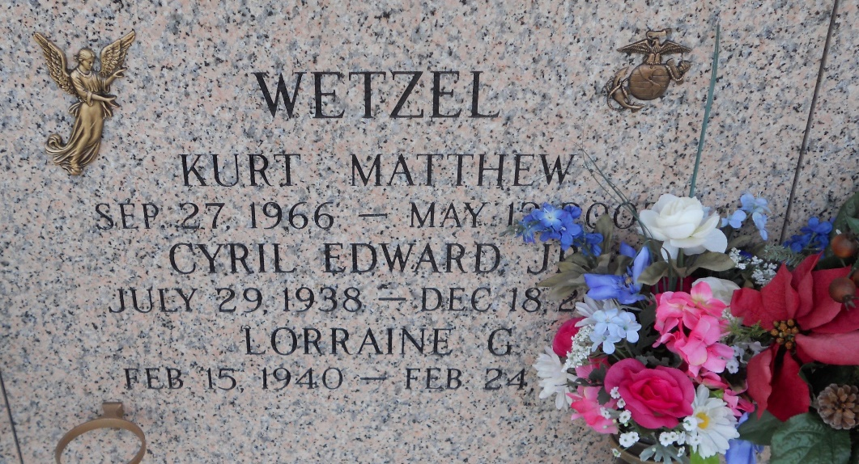

Photo by Team T-Lo

Kurt Matthew Wetzel On Monday, May 12, 2003 At 7:19 Pm. Beloved Son Of Cyril And Lorraine Gausepohl Wetzel. Father Of Jordan Christopher Wetzel. Brother Of Debra W. Mclean, And Michael Wetzel. Age 36 Years. A Native And Lifelong Resident Of Laplace, La.

Relatives And Friends Of The Family Also Employees Of American Sprinkler Company Are Invited To Attend Services. Visitation At Millet Guidry Funeral Home, 2806 West Airline Hwy., Laplace, La On Wednesday, May 14, 2003 From 5-9pm And On Thursday From 10am-12:30pm. Followed By Religious Services In Funeral Home Chapel At 12:30 Pm. Burial In St. John Memorial Gardens, Laplace, La. In Lieu Of Flowers, Donations Requested To The American Cancer Society.

Times Picayune, New Orleans, Louisiana

Mary 14, 2003