Harold White

August 1, 1965 – March 26, 2017

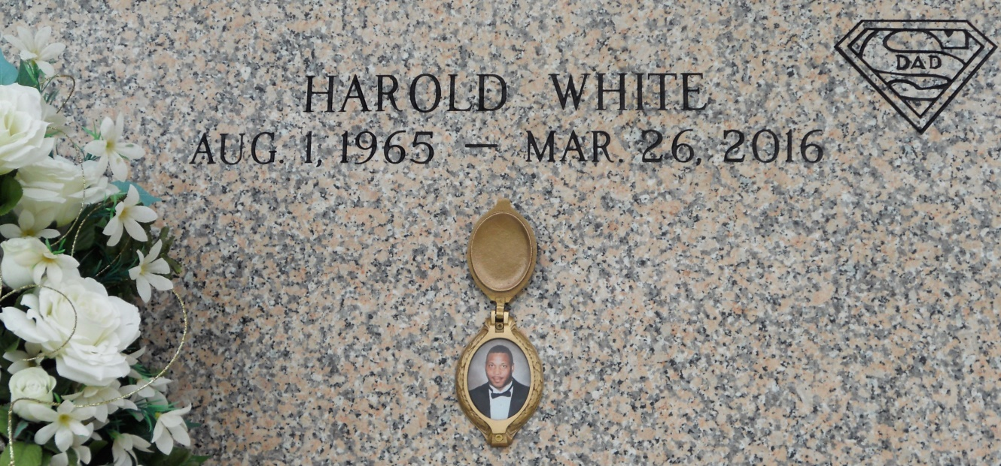

Photo by Team T Lo

Harold White on Saturday, March 26, 2016 at St Charles Hospital, Luling, LA. Son of Bernice W. and Charles White, Sr. Father of Amber F. White and Andra A. White. Brother of Charles White. Jr., Charlotte White Green, Celestine White (Yolanda), Clifton White (Kawanda) and the late Floyd White. Longtime companion of Gaynell Boyd. Grandfather of Taylor M. Knight Godfather of Erica White. Also survived by a host of aunts, uncles, nieces, nephews, cousins, other relatives and friends. Age 50 years. A native and resident of Killona, LA.

Relatives and friends of the family, also pastors, officers and members Little Zion Missionary Baptist Church and all neighboring churches and employees of Veoila Environmental and Hydro Chem Services are invited to attend the Funeral Service at Little Zion Missionary Baptist Church, 2444 West Orice Roth Road, Gonzales, LA on Saturday, April 2, 2016 at 10:00 AM Rev. Graylin Burl, Sr., Pastor, Officiating Interment St. John Memorial Garden Cemetery, LaPlace, LA Visitation at the above named church from 9:00 AM until Service Time SERVICED BY ROBOTTOM

Times-Picayune, The (New Orleans, LA) - Wednesday, March 30, 2016

Contributed by Jane Edson