Thomas E. White

June 3, 1940 – October 9, 2017

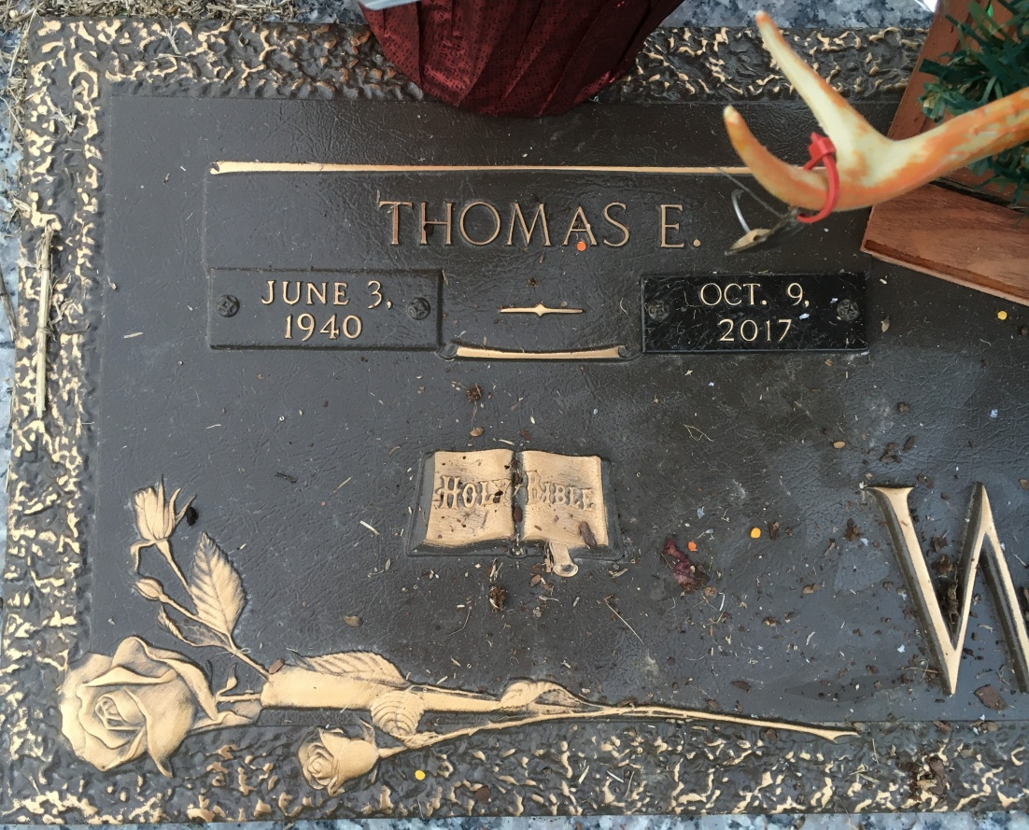

Photo by Team T Lo

Thomas E. White passed away at his residence on Monday, October 9, 2017 at the age of 77. He was a native of Montgomery, AL and a resident of St. Amant, LA. Thomas was a welder in the construction industry.  
 Beloved husband of 39 years to Marie Breaud White. Loving father of Gail Henries (Gary), Thomas “Michael” White and David White (Heather). Step-father of Deborah Malain (Alan), Penny LeBlanc (Kenneth “Kosh”), Chris St. Pierre (Cherie) and the late Gene Raymond St. Pierre and Kenneth St. Pierre. Son of the late Bill and Irene Tanton White. Brother of Gail Harmon (Archie). He was also survived by many grandchildren and great grandchildren.  
 The family would like to extend a special thank you to Dolores Marks with Eagan Hospice for her kindness and great care.  
 Relatives and friends are invited to attend the visitation on Friday, October 13, 2017 beginning at 11:00 a.m. followed by the Religious Service at 1:00 p.m. in the Chapel of Millet-Guidry Funeral Home, 2806 W. Airline Hwy, LaPlace. Interment in St. John Memorial Gardens Cemetery.

Millet-Guidry Funeral Home online obit (accessed 10/10/2017)