Gary Lloyd Wilcox

November 4, 1955 – July 28, 2021

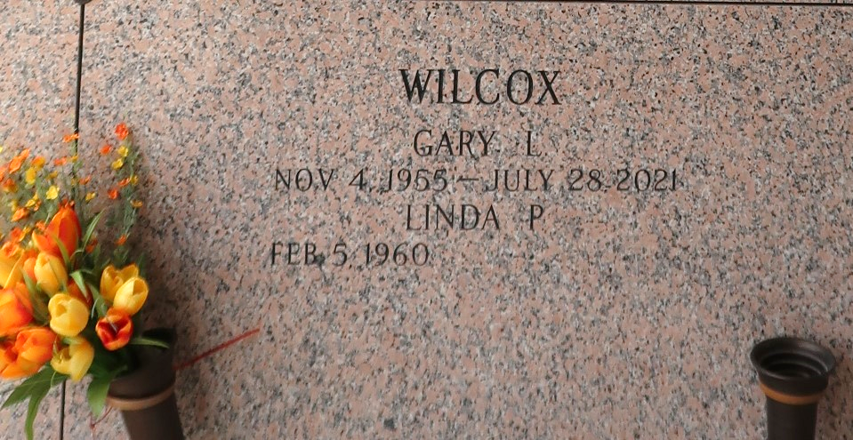

Gary Lloyd Wilcox passed away on Wednesday, July 28, 2021 at the age of 65. He was a native of Shamrock, TX and a resident of LaPlace, LA.
Beloved husband of Linda Pierson Wilcox. Loving father of Joey Wilcox (Chrissy) and Ashley Jamieson (Donovan). Grandfather of Destiney Holley, Carley Wilcox, Gavin Wilcox, Drake Jamieson and Aiden Wilcox. Son of the late Arliss Jean Grauf Wilcox and Lloyd Willard Wilcox. Brother of Wanda McWilliams (Lanny) and the late Toni Jewell (Rodney) and Lisa Wentworth (Holden). Also survived by many other family members and friends.
Relatives and friends are invited to attend the Visitation and Funeral Service at Millet-Guidry Funeral Home, 2806 W. Airline Hwy., LaPlace on Monday, August 2, 2021. Visitation will begin at 10:00 a.m. followed by a Funeral Service at 12:00 p.m. Interment in St. John Memorial Gardens Cemetery, LaPlace, LA.
Please respect the family wishes and wear a mask due to the current increasing numbers of COVID 19 to protect yourself and others that are attending the service.

Millet - Guidry Funeral Home, LaPlace, Louisiana

