James “Rusty” Wilcox

1961 – February 15, 2008

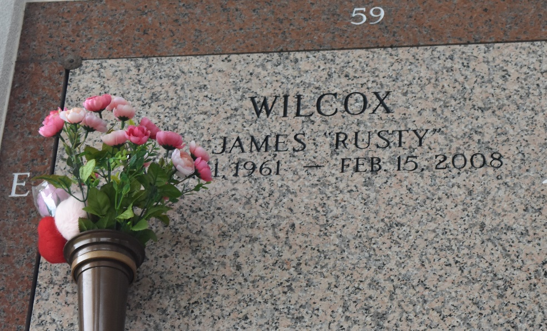

Rusty Wilcox on Friday, February 15, 2008 at 3:05 AM. Beloved husband of Margaret Wilcox. Father of James, Jimmy, Paul, Kristy, Lesley, Rebecca and Gregory. Also survived by 9 grandchildren. Age 46 years, a native of St. Louis, Missouri and a resident of LaPlace and Reserve.

Relatives and friends are invited to attend services. Visitation at Millet-Guidry Funeral Home, 2806 W. Airline Hwy., LaPlace, La., on Tuesday, February 19, 2008 from 8AM to 10AM. Followed by Religious Services at the Funeral Home Chapel at 10AM. Burial in St. John Memorial Gardens Cemetery, LaPlace, La.

The Times-Picayune, New Orleans, Louisiana
Feb. 17, 2008

