Gerald David Wilds

August 24, 1938 – January 20, 2022

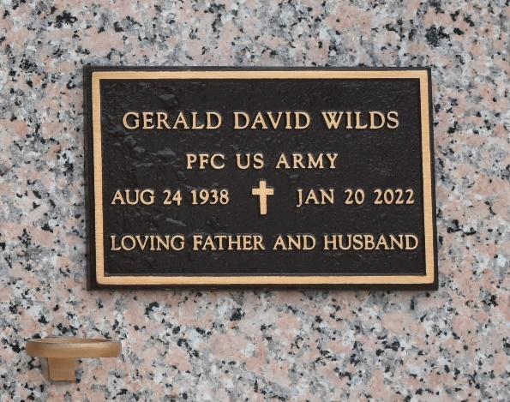

Gerald "Jerry" Wilds, age 83, passed away peacefully surrounded by his family on Thursday, January 20, 2022. Jerry was born on August 24, 1938 in Proctorville, Ohio. After graduating from Windsor High School he enlisted in the US Army. He married the love of his life Faye in 1961 and had 3 children.
He worked at Conner Steel in West Virginia. He later moved to Louisiana to startup Bayou Steel where he worked and retired after 30 years.
His hobbies as a young man were playing music and drag racing. Once retired he turned his attention to restoring classic cars. Jerry was a loving husband and father, cherished and respected by his family and friends. He was a pillar of strength and generously shared his seasoned wisdom.
He was preceded in death by his parents, James and Leota Wickline; wife, Faye Wilds; daughter, Tonya Wilds; sister, Patty Harris; and brother-in-law, James Dean Gibson. He is survived by his children, Angela Oubre and husband Bob, and James Eric Wilds and wife Jennifer; grandchildren, Rob, Craig, and Erika Oubre, Ethan Wilds, and Ayndraea, and Aylana Feeney; great grandchildren, Anthony and Emma Oubre, and Jacob Feeney; brother, Gary Adkins; sisters-in-law, Kay Walker and Judy Gibson; and numerous nieces and nephews.
A private family service will be held at a later date. An on-line guest book is available at www.harrymckneely.com.

The Advocate, Baton Rouge, Louisiana
Jan. 28 to Jan. 30, 2022

