Helen (Joseph) Wilfred

March 14, 1930 – September 4, 2023
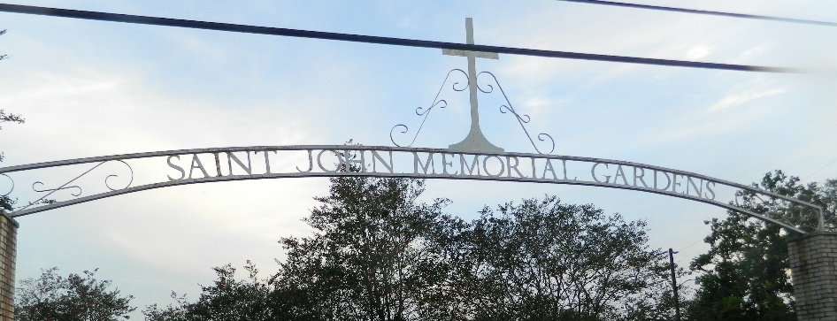

Helen Joseph Wilfred departed this earthly life and entered eternal rest on September 4, 2023. She was the third child born to the late Celestin and Ethel Farlough Joseph, on March 14, 1930. She accepted Christ at an early age and was baptized by Rev. J. J. Farlough in the Mississippi River. She was a lifelong native and resident of Mt. Airy, LA.
Entering Holy Matrimony on August 28, 1947, to Adam Wilfred was one of the many joys in her life. They were the proud parents of two sons, Skippy Eugene and Artie Lee Ray and one daughter, Gail. Even though her physical presence is no longer with us, love never dies.
Helen Joseph Wilfred will always be remembered by her two sons, Skippy Eugene Wilfred of Atlanta, GA and Artie Lee Ray Wilfred of Mount Airy, LA; daughter, Gail Creecy of Reserve, LA; son-in-law, Mark Creecy, Sr.; sister, Glendora Grant; sister-in-law, Laura Joseph; seven grandchildren, Mark, Jr. (Latunya), Jamaal, Marlon and Jayna Creecy, Tanisha (Aaron) Laudman, Tammy Wilfred and Terri Wilfred; seventeen great-grandchildren, three great-great grandchildren; two godchildren, Peggy Barrow and Donald Ray Jones; and a host of extended family of nieces and nephews, other relatives, friends and the Mount Airy community.
Nanny, our term of endearment, is preceded in death by her husband, Adam Wilfred; parents, Ethel and Celestin Joseph, Sr.; siblings, Adeline Alexis, Larry Joseph, Sr., Celestin Joseph, Jr., Sybil Joseph, Lionel Joseph and Stanley Joseph, Jr.
Family and friends are invited to the homegoing celebration on Saturday, September 16, 2023, at 10 a.m. at St. Mark Baptist Church, 132 Marquez St, Mt. Airy, LA 70076. Viewing will be from 8 a.m. until service time. Interment: St. John Memorial Gardens, LaPlace, LA. Visitation will be held on Friday, September 15, 2023, from 3 pm – 6 pm at Bardell's Mortuary, 3856 LA 44, Mt. Airy, LA 70076.
The Times-Picayune, New Orleans, Louisiana
Sep. 14 to Sep. 15, 2023

