Lucinda (Porter) Wilkens

May 31, 1941 – October 15, 2020
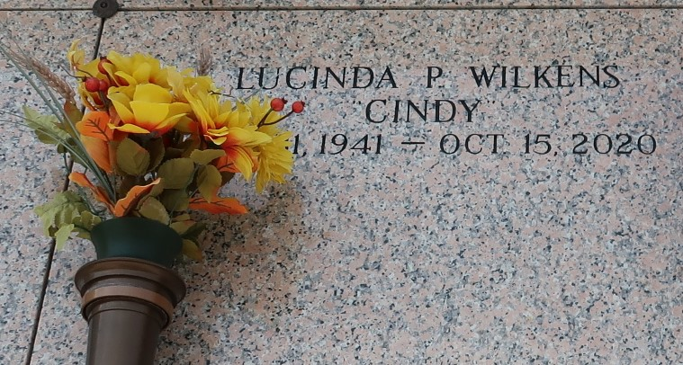

Lucinda Porter Wilkens, affectionately known as "Cindy," departed this life on Thursday, October 15, 2020 at her residence in LaPlace surrounded by her loving family. Daughter of the late Simon and Ethel Butler Porter. She was the sister of Sally Porter Reynolds and the late John Calvin Porter. Beloved Mother of Ethel Rani Stemley (Raymond) and Holly Wilkens Shelvin (Carl). She is also survived by four grandchildren, six great-grandchildren, two god-children and a host of nieces, nephews and cousins. Sis. Lucinda was a devoted and dedicated member of the Rising Star Baptist Church of LaPlace.

Relatives and friends of the family are invited to attend a Visitation on Friday, October 23, 2020 from 5:00pm-7:00pm at Patrick H. Sanders Funeral Home located at 605 Main Street, LaPlace, LA. Visitation will continue on Saturday, October 24, 2020 at Rising Star Baptist Church 620 Cardinal Street, LaPlace, LA. from 8:00am until the commencement of the funeral service at 10:00am. Rev. Donald R. August Sr., Pastor/Officiating. Interment will follow at St. John Memorial Gardens 2205 W. Airline Hwy., LaPlace, LA.

Patrick H. Sanders Funeral Home, LaPlace, Louisiana

