Leona (Bush) Willette

May 18, 1922 – March 2, 2012

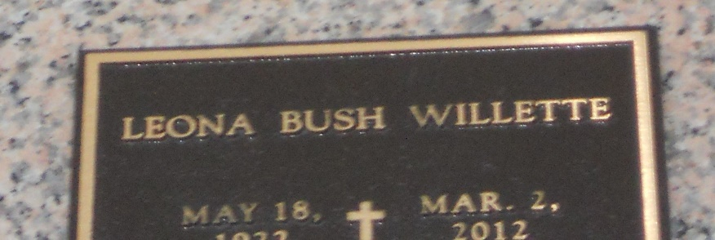

Photo by Team T-Lo

Leona Bush Willette passed away on Friday, March 2, 2012. Beloved wife of the late Julio Willette. Mother of Debbie Druin (George). Grandmother of Geoff Druin and Kelly Sievertson. Great - grandmother of Geoffrey, Jr., Shelby, Ashley and Grayson. Daughter of the late Emile and Mary Bush. Sister of Audrey Scafidel, Jean Mascair and the late Verna Thezan, Wilson Bush, Dan Bush, Leonard Bush, Marvin Bush, Beulah Freeman and Eloise Bush. Age 89 years. A native of Abita Springs, LA and a resident of LaPlace, LA.

Special thanks to River Parishes Hospital, Southeast Louisiana War Veterans Home and Generations Hospice.

Relatives and friends are invited to attend services. Visitation at Millet-Guidry Funeral Home, 2806 W. Airline Hwy., LaPlace, LA on Tuesday, March 6, 2012 from 10:00AM until 11:00AM followed by Religious Services in the Funeral Home Chapel at 11:00AM. Burial to be private at a later date. In lieu of flowers, donations preferred to Little Sister's of the Poor, P.O. Box 741028, New Orleans, LA 70174-1028.

The Times-Picayune, New Orleans, Louisiana

Mar. 2 to Mar. 4, 2012