Alfred Williams Sr.

October 3, 1956 – September 26, 2013

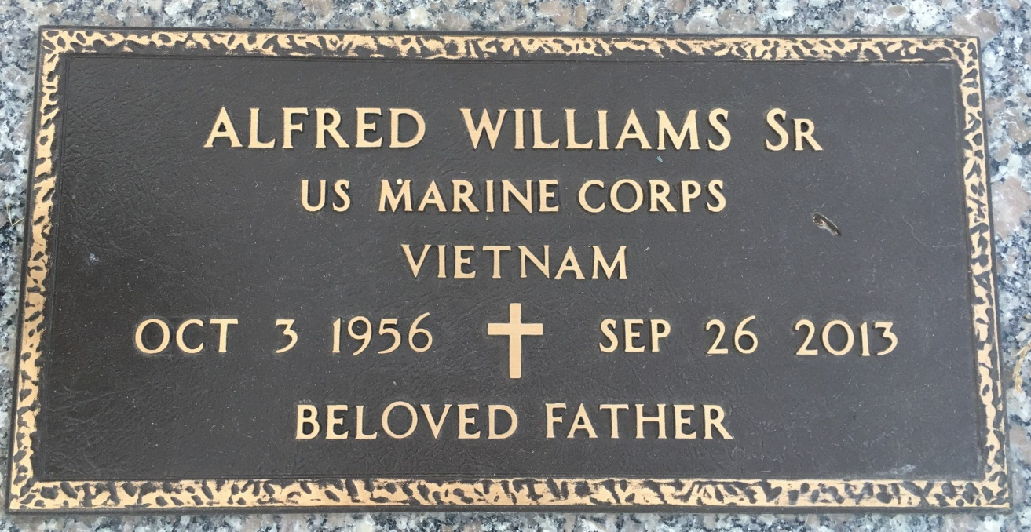

Photo by Team T Lo

ALFRED WILLIAMS, SR. (FROG) on Thursday, September 26, 2013 at River Parishes Hospital, LaPlace, LA. Son of Lorraine Johnson Williams and the late Thomas T. Williams, Sr. Father of Alfred Williams, Jr. (Brandy), Andre Williams and Latoya Snyder. Brother of Thomas Williams, Jr., Lorraine Francois (Cornell), Cathy White (Willie), Angela Gabriel (Thomas), Mary Emma Williams, Floyd Williams, Ralph Williams, Beverly Williams and the late Mauldon Jones. Also survived by 2 grandchildren and a host of nieces, nephews, cousins, other relatives and friends. Age 56 years. A native and resident of Reserve, LA  
  
Relatives and friends of the family, also pastors, officers and members of Tchoupitoulas Chapel and all neighboring churches are invited to attend the funeral service at Tchoupitoulas Chapel, 1022 Highway 44 (River Road), Reserve, LA on Saturday, October 5, 2013 at 10:00 AM. Rev. Lionel Murphy, Pastor, Officiating. Interment St. John Memorial Garden Cemetery, LaPlace, LA. Visitation at the above named church from 9:00 AM until service time.  
  
ROBOTTOM MORTUARY

Times-Picayune, The (New Orleans, LA) - Friday, October 4, 2013

Contributed by Jane Edson