Allen Williams

June 29, 1963 – May 12, 2023

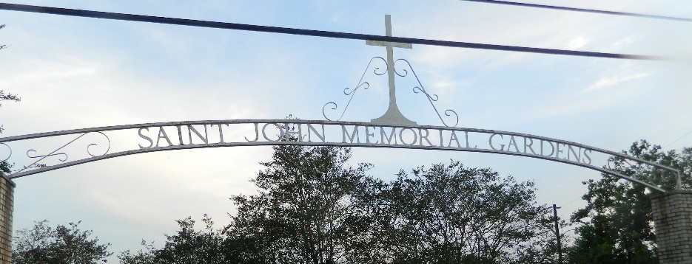

VILLE PLATTE-Funeral services for Allen "Pookie" Williams will be held on Saturday, May 20, 2023, at 11:00 A. M. with the visitation beginning at 9:00 A. M. at Owens-Thomas Funeral Home in Ville Platte, LA. Burial will be in St. John Memorial Gardens. Rev. Freddie Jack will officiate the funeral ceremony.
On Friday, May 12, 2023, at 10:57 P. M., Allen Williams heard the voice of Jesus saying "Come home and be at rest".
Mourning his departure are his parents: Landrus and Emma Joy Williams both of Ville Platte, LA; one son: Jacoby Simon of Houston, TX; one daughter: Revella Lafleur of Ville Platte, LA; three grandchildren; four brothers: Warren Williams and Arlen (Gidgett) Williams both of Lake Charles, LA, Walter (Tabitha) Williams and Dereck (Jalyn) Williams both of Ville Platte, LA; three sisters: Judy (Wayne) Charles of Lake Charles, Betsy (Shawn) Pitre and Loulla (Roedrakass) Pitre both of Ville Platte, LA; his companion: Rose Sias of Lake Charles, LA; and a host of other relatives and friends.
He was preceded in death by one brother: Randy Williams.
Owens-Thomas Funeral Home, Ville Platte, Louisiana

