Dorothy W. Williams

February 3, 1937 – December 2, 2017

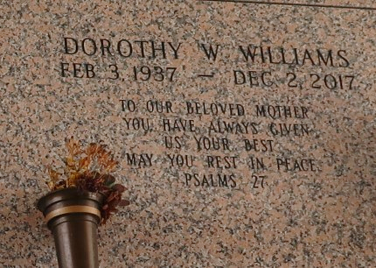

Dorothy W. Williams departed this life on Saturday, December 2, 2017 at Ochsner Clinic Foundation in Laplace, LA. Daughter of the late Gladys Young Gray and Walter Wilson, Mother of Donald, Kevin (Margaret), Michael (Karen,) Lionel, Gerald, Darryl (Patricia), Kendrick Williams, Gail (Kerry) Felton, Cynthia (Bill) Brown, Crystal Jenkins and Jaimie Williams and the late Barbara Jean Williams and Patriia Easly. Sister of Joyce (Wilfred) Randall, Linda (Larry) Joseph also survived by grandchildren, great grandchildren, nieces, nephews, god children and a host of family and friends.
Funeral service on Saturday December 09, 2017 at 11:00 am at Providence B.C. #1 228 pine St. Laplace, LA 70068. Rev. Willie Smith officiating. Viewing from 9:00 am until service time. Interment: St. John Memorial Gardens, Laplace, LA Rising Star B.C. and all neighboring churches, Dr. Cusco and Staff of Ochsner Heath center river parishes are invited to attend. Service entrusted to HOBSON BROWN FUNERAL HOME, 134 DAISY ST. GARYVILLE, LA. 985-535-2516

The New Orleans Advocate, Louisiana
Dec. 6 to Dec. 9, 2017

