Jacob A. Williams
March 19, 2004 – June 2, 2005

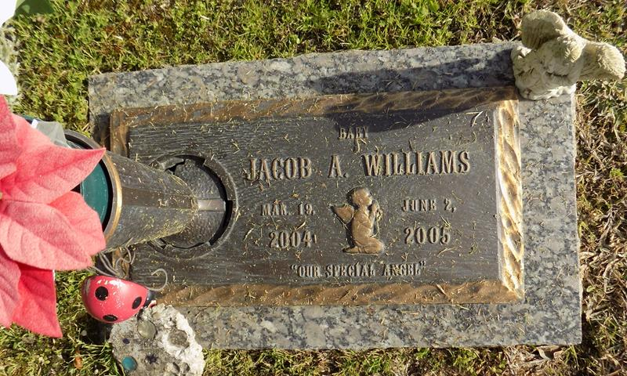

Jacob A. Williams On Thursday, June 2, 2005 At 10:34 A.M. Beloved Son Of Adam And Michelle Brouwer Williams. Brother Of Morgan Williams. Grandson Of Michael And Cheri Williams And Michael Brouwer And The Late Ina Brouwer. Age 14 Months. A Native And Resident Of Reserve, La.
Relatives And Friends Of The Family Are Invited To Attend Services. Visitation At Millet Guidry Funeral Home, 2806 West Airline Highway, Laplace, La On Saturday, June 4, 2005 From 11:00 A.M. Until 12:45 P.M. Followed By Religious Services At St. Joan Of Arc Catholic Church, Laplace At 1:00 P.M. Burial In St. John Memorial Gardens, Laplace.
Times Picayune, New Orleans, Louisiana
June 3, 2005

