Jayson Michael Williams Sr.
November 1, 1984 – November 8, 2022
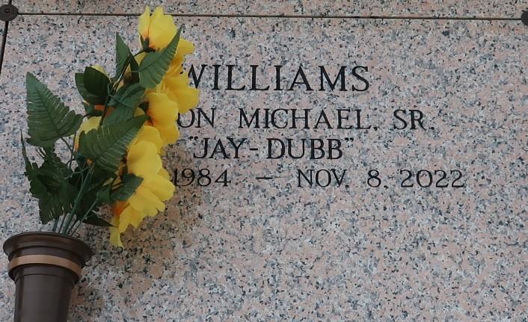
The birth of Jayson Michael Williams Sr was planned in the mind of God before he was conceived by his parents Percy Williams and Vader Fobb-Wilson. God knew the date of his birth November 1, 1984, and the date of his death November 8, 2022, in Lutcher, La. Jayson was baptized at an early age at Rising Star Baptist Church in Laplace, La., by the late Rev. Clarence Alvis Sr. He later moved his membership to First Community Antioch Baptist Church in Lutcher, La., under the leadership of his uncle the late Rev. Ferdinand Gaines Jr and continued under the leadership of Dr. Steven D. Beckham. Jayson was a 2003 graduate of East St. John High School. Affectionately given the nickname Jay-Dubb by his peers, he truly left his marked on everyone he encountered while walking the halls at ESJH. While at East St. John Jayson actively participated in the Beta Club, Science Club, and ESJH Fellowship Christian Athletic Club. Jayson was also a part of ESJHS football program and received many awards. He graduated as a member of the Top 20 in his graduating class. After graduating from ESJH Jayson received a football scholarship to attend Alcorn State University. Jayson’s personality gained him many friends during his college career. It was at Alcorn that he was given the nickname “Banner.”
However, Jayson’s greatest blessing, occurred on November 4, 2011, when God blessed him and Brionika Taylor with a son, who was given his father’s name Jayson Michael Williams Jr. Jayson Sr, and Jayson Jr affectionately called one another Da-dee. Jayson Jr was truly the apple of his father’s eyes. Jayson enjoyed life to the fullest. He enjoyed fishing, hunting, dancing, hanging out with his friends and family, riding the 4-wheeler with his son, but most of all spending time with his son. In high school Jayson was voted “Most likely to party on a school night.” Jayson was the life of any party on any occasion. He never met a stranger that did not fall in love with his “living life” attitude. Jayson was gainfully employed by ADM in Reserve, La, until the time he passed.
Jayson leaves to cherish his and celebrate his memory his son Jayson Michael Williams Jr. His parents Percy Williams and Vader Fobb Wilson, sisters; Kenya Wilson and Ryshique Williams. Three nieces Deznee, Dante and Denim. A devoted fiancée Antoinette Jones. He unconditionally participated in the rearing of Chris Nicholas which included being a loving grandfather figure to Carter Nicholas. He was also a loving father figure to JaKyria, JaKeiya, and Jameire Taylor. Aunts: Claudia and Peggy Fobb, Linda Bailey, and Katherine Williams. Uncles; Herfert and Stuart Fobb, Lionel Bailey Sr., and Edward “Gene” Johnson. Lastly WQP (Woodland Quarters Posse), a community of love, that loved Jayson, and Jayson loved back.
Jayson is preceded in death by his grandparents Abraham and Vivian Williams Sr., and Herfert and Onie B. Fobb. Seven uncles and five aunts. Two special cousins Jerome James Fobb and Edward “Kendall” Johnson. Jayson was a one in a million who was loved by everyone. He will be missed by everyone.
Relatives and friends are invited to attend a public visitation Friday, November 18, 2022, from 5pm-7pm at First Community Antioch Baptist Church 10860 Hwy 3125, Gramercy, LA 70052. Visitation will be held from 9AM-11AM Saturday, November 19, 2022. A celebration of life will be held Saturday, November 19, 2022 at 11 a.m. at First Community Antioch Baptist Church, 10860 Hwy 3125, Gramercy, LA 70052. Rev. Steven Beckam officiating. Interment will follow at St. John Memorial Gardens Laplace, LA 70068.

Treasures of Life Funeral Services, Gramercy, Louisiana

