Jeremiah A. Williams

March 31, 1999 – November 27, 2012

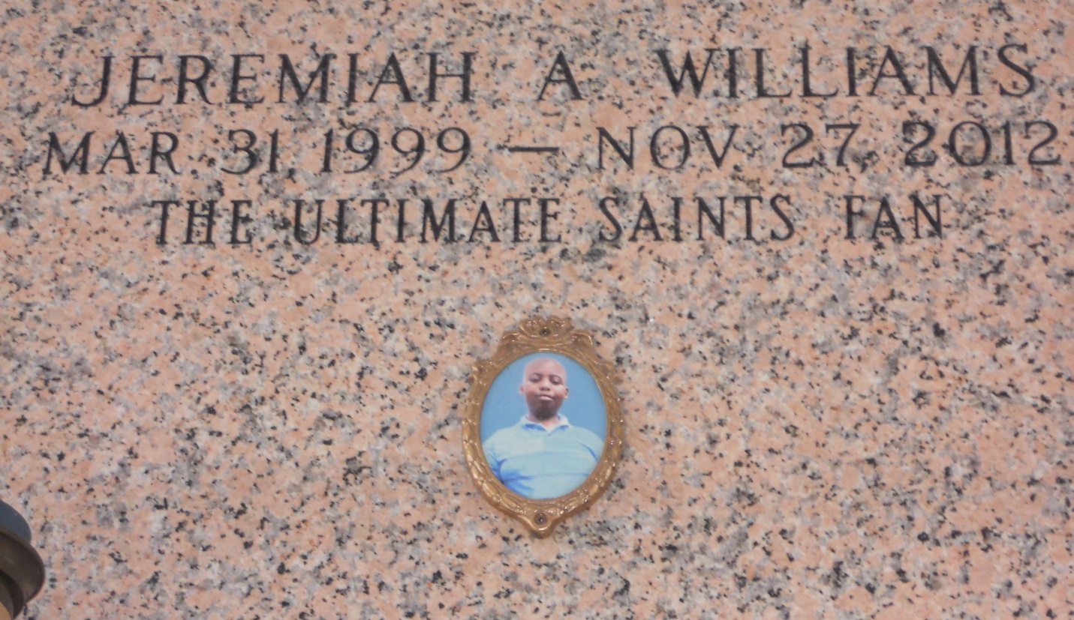

Photo by Team T Lo

Jeremiah "Took" Williams passed away on Tuesday, November 27, 2012, at the age of 13 years old. Son of Leslie Williams and Allan Holland, Jr. Grandson of Margie and Walter Conner, Kelvin Webber, Allan Holland, Sr. and the late Rosemary Washington. Brother of Jamirah and Josiah Williams. Also survived by a host of aunts, uncles, cousins, other relatives and friends.  
  
Funeral services will be held on Wednesday, December 5, 2012 for 11:00 a.m. at Destiny Christian Center, 612 Main Street, Laplace, La. Pastor Steve O. Allen, Sr. will be officiating. Visitation will be from 9:00 a.m. until time of service. Interment will be at Memorial Gardens Cemetery, Laplace, La.

Funeral entrusted to The Baloney Funeral Home, LLC., 399 Earl Baloney Street, Garyville, La., 985-535-2540. Condolences can be expressed at [www.baloneyfuneralhome.com](http://www.baloneyfuneralhome.com/).

Times-Picayune, The (New Orleans, LA) - Sunday, December 2, 2012

Contributed by Jane Edson