Kevin L. Williams Sr.
May 2, 1972 – December 21, 2019
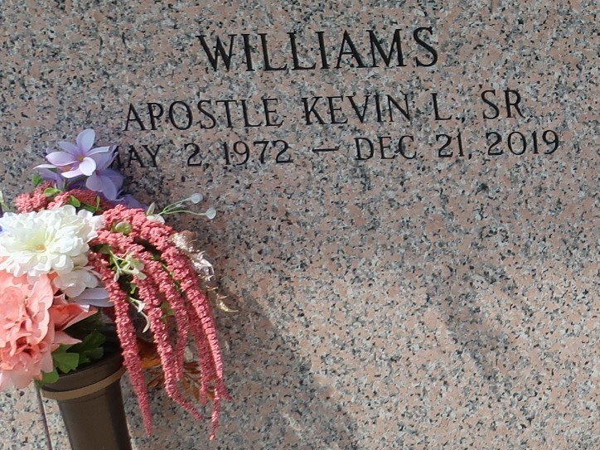

Apostle Kevin L. Williams Sr. was born May 2, 1972, in New Orleans, Louisiana to Pernell L. Williams Sr. and the late Marilyn Landix Berzat.
Apostle Kevin is a graduate of East St. John High School and attended Southern University. He devoted many of his working years to Bayou Steel, and later became an entrepreneur as owner of Williams and Son Trucking and Lawn Care Services; as well as Williams Sweet Treats.
On Saturday, December 21, 2019, Kevin sowed his natural body and was raised a spiritual body (I Cor. 15:44). Kevin was instrumental in the outreaches of Charity Hospital, New Orleans Mission, Twin Oaks Nursing Home, Ormond Nursing Home, Street Evangelism, and St John Parish Prison Ministry.
All are invited to attend funeral arrangements on Saturday, December 28, 2019 at Renewal Outreach Ministries, 920 Oxley Street, Kenner, La. Visitation 9-10 am; Service at 10:00 am. Interment will follow at St John Memorial Garden in Laplace, La.

The Times-Picayune, New Orleans, Louisiana
Dec. 26 to Dec. 28, 2019

