Kitty M. Williams
January 15, 1941 – January 12, 2003

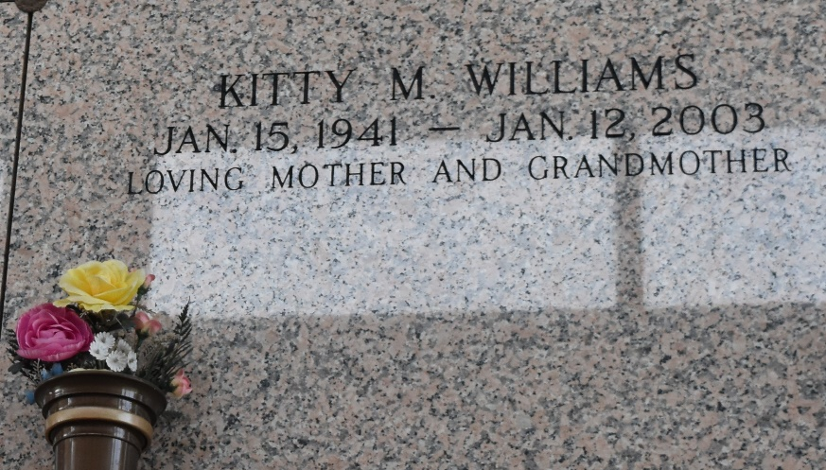

Kitty Williams Departed This Life On Sunday January 12, 2003 At Kenner Regional Hospital, Kenner, La. Daughter Of The Late James And Edna Williams. Mother Of Yolanda Jefferson. Grandmother Of Darris Washington, Kyroneka And Miychneka Jefferson. Mother-In-Law Of Kenneth Jefferson All Of Tacoma Washington. Sister Of James, Matthew, And Rev. George Williams, Viola Telfair, Jessie Smith, Audrey Vinnette Julia And Ruth Williams. Sister-In-Law Of Rev. Joseph Smith, Isiah Telfair Jr., Charles Vinnette, Jackie And Janice Williams And A Host Of Nieces, Nephews, Aunts, Uncles Other Relatives And Friends.

A Native And Resident Of Reserve La. Age 61. Relatives And Friends Pastors Officers And Members Of New Pilgrim Baptist Church And All Neighboring Churches Are Invited To Attend The Funeral Services On Monday January 20, 2003 At 12:00 Noon Rev. Forell Bering Pastor Officiating. Interment In St. John Memorial Gardens Laplace, La. Visitation On Monday At The Church From 10:00 A.M. Until Funeral Time. Services Entrusted To: Hobson Brown Funeral Home Garyville, La.
Times Picayune, New Orleans, Louisiana
January 19, 2003

