Markeshia Marie Williams

February 20, 1989 – September 9, 2016

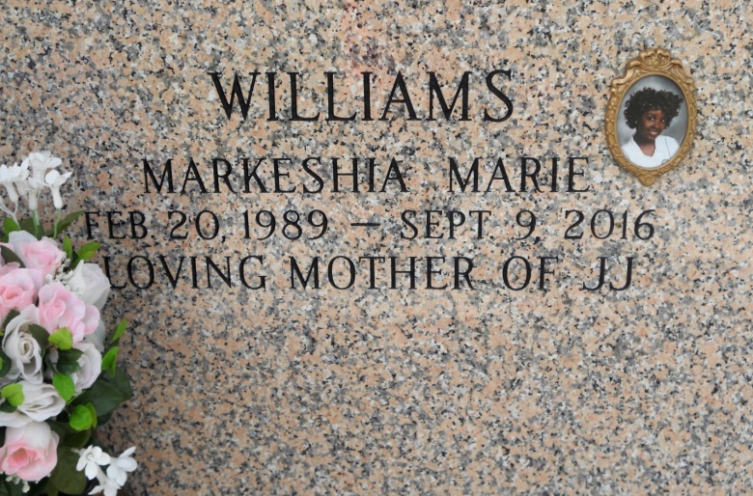

Photo by Team T Lo

1 woman killed, 1 critically injured in I-10 accident in LaPlace

A 27-year-old LaPlace woman was killed Friday (Sept. 9) and her passenger critically injured after Louisiana State Police say she lost control of her car and hit a sign on Interstate 10. The accident happened around 12:30 p.m. near the Belle Terre exit in LaPlace, authorities said.  
 The driver, identified by State Police as Markesha Williams, was taken to a local hospital and later died. Her passenger, identified as Rachelle Jackson, 30, of LaPlace, was taken to University Medical Center in New Orleans in critical condition, according to State Police.  
 Authorities say Williams may have been speeding when she lost control of the 2009 Toyota Camry as she drove east on I-10. The car ran off the road to the right and struck a message board sign on the passenger side of the vehicle, according to the police report.  
 Authorities say they don't know at this time whether seat belts were used or if the driver was impaired. A toxicology test is pending an autopsy. State Police believe speeding may be a factor, and the accident remains under investigation, authorities said.  
  
Times-Picayune, The: Web Edition Articles (New Orleans, LA) - Saturday, September 10, 2016 Contributed by Jane Edson

*****

Markeshia Marie Williams transitioned to her heavenly home on Friday, September 9, 2016, at the age of 27, due to injuries sustained in a vehicle accident. Markeshia was born on Feb. 20, 1989. She was a life-long resident of Laplace, LA. and worked as a Registered Nurse for Ochsner (Main Campus) Medical Center in Metairie, LA.

Markeshia was the beloved mother of Ja’leyah Woodard. She was loved and will be forever missed by her father and mother; Kevin and Margaret Williams, maternal grandparent Doris Robertson and fraternal grandparent Dorothy Mae Wilson and a host of uncles, aunts, cousins, friends, church family, and co-workers.  
 The family invites everyone to attend the services celebrating Markeshia’s life on Saturday, September 17, 2016 at First Assembly of God, 3001 New Hwy. 51 Laplace, LA., Pastor John A. Foster-officiant. Visitation will be held for 10:00 a.m. until 11:00 a. m. Services immediately following. Interment St. John Memorial Gardens, 2205 W Airline Hwy, Laplace, LA 70068.   
 Her final care has been entrusted to Treasures of Life Center for Life Funeral Services.

[www.treasurefunerals.com](http://www.treasurefunerals.com) (accessed 10/18/2018)