Medrick Williams Sr

October 12, 1924 – July 31, 2008

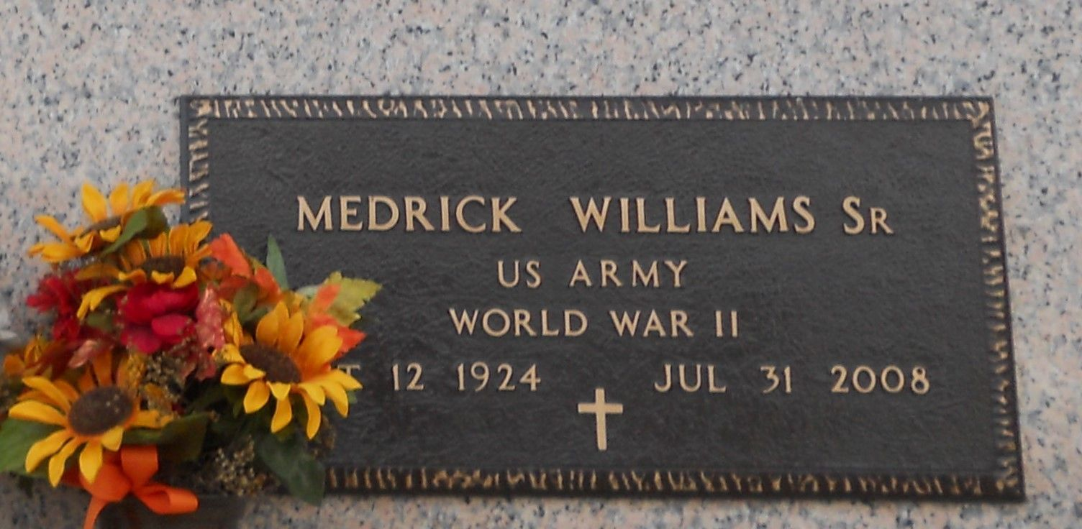

Photo by Team T Lo

Rev. Medrick Williams, Sr. on Thursday, July 31, 2008 at his residence in Reserve, LA. Son of the late Lasker and Beatrice Williams. Husband of the late Rosalie Williams. Father of Deloyd Williams (Sharon), Verna Warren (Benjamin), Lionel Williams (Cheryl), Aline Zeno (Rev. Edgar), Marva Joseph (Melvin, Jr.), Yvonne Smith (Juansley), Medrick Williams, Jr. (Gwen), Norma Dorris, Marilyn Warren (Samuel, Jr.), Joyce Bush (Michael), Marlene Watkins (Rev. Irvin), Sheryl Pierre (Alexis), Rose Francois (Timothy, Sr.), Gerald Williams (Shalonda) and the late Bernadine Batiste (Bruce, Sr.). Brother of the late Juanita Rodgers and Rev. Haskel Williams. Also survived by 29 grandchildren, 9 great-grandchildren and a host of nieces, nephews, other relatives and friends. Age 83 years. A native of Napoleonville, LA and a resident of Reserve, LA.  
  
Relatives and friends of the family, also pastors, officers and members of Greater Morning Star Baptist Church and all neighboring churches are invited to attend the Funeral Service at Greater Morning Star Baptist Church, 1003 Balsam Street, LaPlace, LA on Friday, July 8, 2008 at 11:00 AM. Rev. Bryant Warren, Pastor, Officiating. Interment St. John Memorial Garden Cemetery, LaPlace, LA. Visitation at the church from 9:00 AM until service time.  
  
SERVICED BY ROBOTTOM

Times-Picayune, The (New Orleans, LA) - Thursday, August 7, 2008

Contributed by Jane Edson