Tammy Williams

July 30, 1974 – December 20, 2006

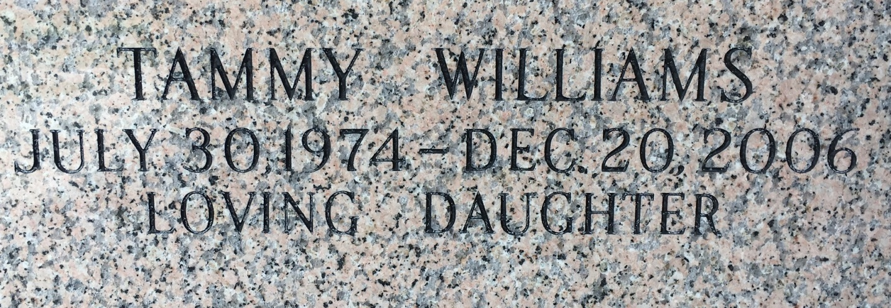

Photo by Team T Lo

Tammy Williams on Wednesday, December 20, 2006 at Earl K. Long Hospital in Baton Rouge of cardiac arrest. Beloved daughter of Ursula and Louis Williams, Sr. Sister of Keltrice, April, Louis, Jr., and Arnold Williams. Granddaughter of Marion Brown.  
  
Friends and relatives are invited to attend a funeral service on Thursday, December 28, 2006 at 10:00 a.m. at Christian Mission Baptist Church, 1477 N. Robertson St., NOLA. Interment in Providence Park. Visitation starting at 9:00 AM. Thibodaux's Funeral Service in charge of arrangements.

Times-Picayune, The (New Orleans, LA) - Wednesday, December 27, 2006

Contributed by Jane Edson