Wade Williams Jr.
January 28, 1946 – March 29, 2020

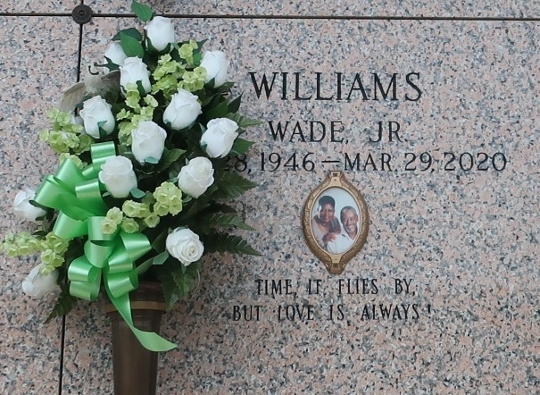

Wade 'Bo' Williams transitioned on Sunday, March 29,2020 at Ochsner Hospital in Jefferson, LA. He was the son of the late Annie and Wade Williams Sr. He resided in Reserve, LA., and was a former employee of Colonial Sugar Refinery in Gramercy, LA. He was the husband of Patricia L. Williams, whom he was married to for 36 years.
Wade also leaves to cherish his precious memories his children, Patricia, Pamela, Wade (Tameka), Sean (Rochelle), Chad (Tai), Brandi and Dustin (Brittany); two sisters, Rose Craft and Annie B. Moffet, and a host of grandchildren, great-grandchildren, nieces, nephews, and other relatives and friends.
He was preceded in death by his mother and father, three sisters and a brother.

Treasures of Life Funeral Services, Gramercy, Louisiana

