Audrey Mae (Anderson) Wilson

September 24, 1939 – March 23, 2004

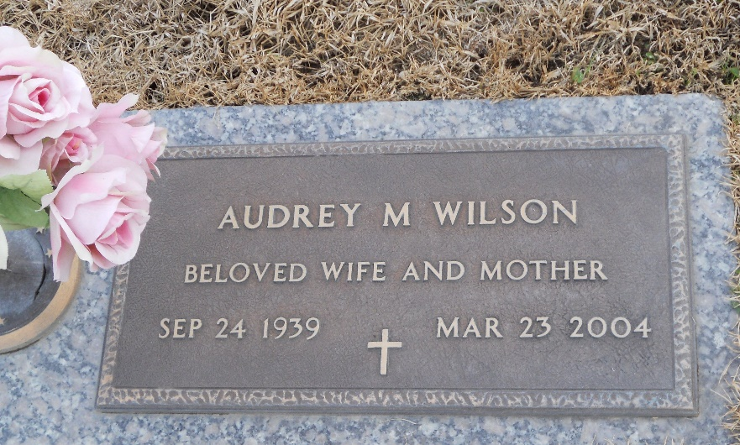

Photo by Team T-Lo

Audrey Mae Wilson On Tuesday, March 23, 2004 At Kindred Hospital, New Orleans, La. Age 64 Years. A Native And Resident Of Laplace, La.  
 Wife Of The Late Ignatius 'Chief' Wilson, Sr. Daughter Of Felice Creecy Brown And The Late Freddie Anderson, Sr. Mother Of Ignatius Wilson, Jr., Keith Wilson, Sr. And Ron Wilson, Sr. Sister Of Octave, Larry, Joey, Randolph, Danny And Clayton Anderson, Mary Ann Parquet, Anita Clement, Elisa Perilloux, Freddie Lee Brown, Brenda Exum And The Late Sylvia Anderson. Mother-In-Law Of Tawanda Palmer Wilson, Erika Breaux Wilson And Larhonda Gaines Wilson. Also Survived By 7 Grandchildren And A Host Of Nieces, Nephews, Other Relatives And Friends.  
 Relatives And Friends Of The Family, Also Pastor, Officers And Members Of Beech Grove Baptist Church And All Neighboring Churches Are Invited To Attend The Funeral Service At Beech Grove Baptist Church, 117 Beech Grove Drive, Reserve, La. On Friday, March 26, 2004 At 11:00 A.M. Rev. Wesley Anderson, Sr., Pastor, Officiating. Interment St. John Memorial Garden Cemetery, Laplace, La. Visitation At The Above Named Church From 9am Until Service Time. Service By Robottom.

The Times-Picayune, New Orleans, Louisiana

March 25, 2004