John Wilson Jr.

November 1, 1942 – August 26, 2008

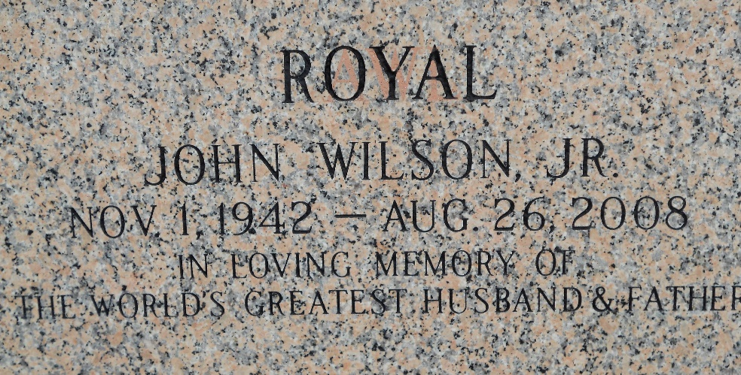

Photo by Team T-Lo

 John "Royal" Wilson, Jr. on Tuesday, August 26, 2008 at River Parish Hospital, LaPlace, LA.

Son of Artemise Rebecca McCray and the late John Wilson, Sr. Husband of Arie Brown Wilson. Former husband of Lorenza (Kay) Roberts. Father of Sheree, Shannon, Shanel and Shondel Wilson and Demetrius (DJ) Holloway. Stepfather of the late Larry Holloway. Brother of Loretta Scott (Don). Also survived by 10 grandchildren, 1 great grandchild and a host of aunts, uncles, nieces, nephews, other relatives and friends. Age 65 years. A native of Edgard, LA and a resident of LaPlace, LA.

Relatives and friends of the family, also pastor, officers and members of New Wine Christian Fellowship Church and all neighboring churches are invited to attend the funeral service at New Wine Christian Fellowship Church, 1929 West Airline Highway, LaPlace, LA, on Friday, August 29, 2008 at 12 noon. Pastor Neil Bernard, Officiating. Interment St John Memorial Garden Cemetery, LaPlace, LA. Visitation at the above named church from 11:00 AM until service time. SERVICED BY ROBOTTOM

The Times-Picayune, New Orleans, Louisiana

Aug. 28, 2008