Lois (Gracianette) Wiltz

February 6, 1923 – September 19, 2011

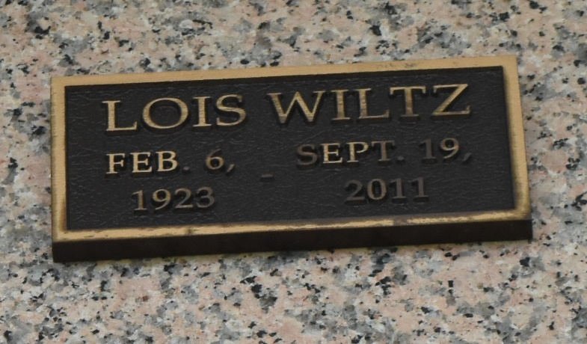

Lois Gracianette Wiltz, 88, resident of Twin Oaks Nursing Home, LaPlace, Louisiana, died on September 19, 2011, of congestive heart failure. Lois was born February 6, 1923, in New Orleans, to the late Louis and Marguerite Wade Gracianette and was the former wife of the late Alcine Joseph Wiltz, Jr.

She is survived by three children: Alcine J. Wiltz, III (Nancy) of Mt. Airy, MD; Darlene Wiltz Wempren (Allen) of LaPlace, LA; and Arthur F. Wiltz (Darlene Fagan) of Metairie, LA. Also surviving are six grandchildren: Allen P. Wempren, Jr. of Houston, TX; Sherry Wempren Hubbard of LaPlace, LA; Michelle Wiltz Clemovich of Spotsylvania, VA; Dena Wempren of Montz, LA; Stefan Alcine Wiltz of Damascus, MD; and Shane Arthur Wiltz of Metairie, LA; 12 great-grandchildren: Kailey and Brandon Hubbard; Holly, Cody, Corey, Kerry and Casey Ford; Abigail, Emma, and Caroline Wiltz; Jac and Katey Clemovich; and one great-great grandchild, Brynlee Ford.

The family will receive friends on Monday, October 3, from 1:00 - 2:30 p.m., followed by a Memorial Service, at the Millet-Guidry Funeral Home, 2806 W. Airline Highway, LaPlace, LA. In lieu of flowers, memorial contributions may be made to Twin Oaks Nursing Home's Activity Fund, 506 W. Fifth Street, LaPlace, LA 70068.

The Times-Picayune, New Orleans, Louisiana

Sep. 27 to Sep. 30, 2011