Eveline T. Winters

February 4, 1934 – November 21, 2010

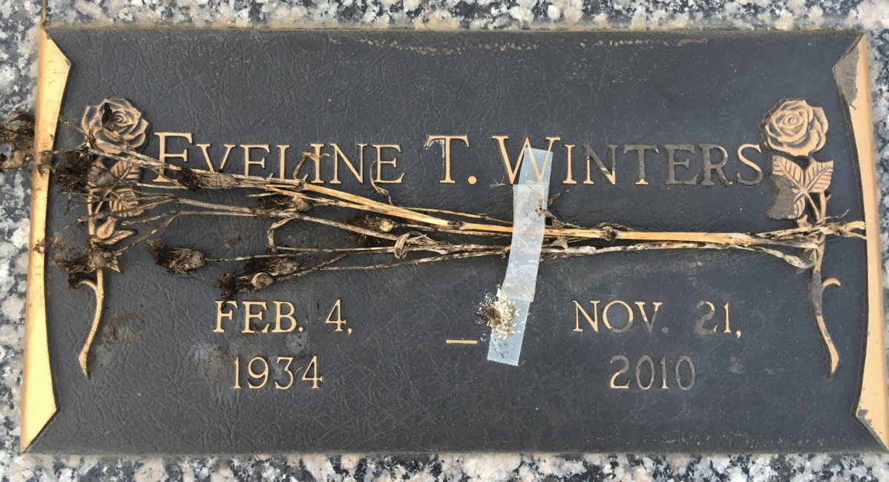

Photo by Team T Lo

Eveline T. Winters passed on to be with the Lord on Sunday, November 21, 2010.   
She was 76.

Beloved wife of the late Warren L. Winters.   
Mother of George Berthelot, Micheline Metzler, Warren L. Winters, Jr., Wanita W. Midkiff and the late Danielle Pugh.   
She is survived by 11 grandchildren and 11 great-grandchildren. She will be missed by all.   
  
Relatives and friends are invited to attend services. Visitation will be on Wednesday, November 24, 2010 at First Baptist Church, 268 W. 10th at Railroad Avenue, Reserve, LA from 8:30 a.m. until 10:00 a.m. Followed by a Religious Service at 10:00 a.m. at the church. Burial will be in St. John Memorial Gardens Cemetery, LaPlace, LA.

Unknown source