Warren L. Winters Sr.

August 30, 1934 – October 21, 2000

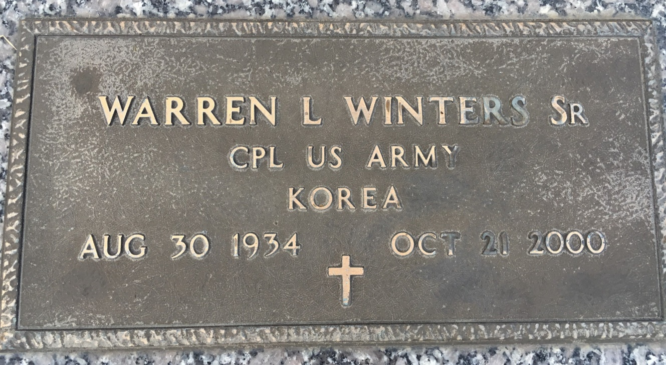

Photo by Team T Lo

LAPLACE Warren L. Winters Sr., 66, a native of New Orleans and resident of LaPlace for 30 years, died Oct. 21. He was the husband of Eveline Winters and father of George Berthelot, Mickey Metzler, Warren Jr. and Wanita Winters and the late Danielle Pugh. He is also survived by nine grandchildren and two great-grandchildren. Services were Oct. 24 in the chapel of Millet-Guidry Funeral Home, LaPlace, with interment at St. John Memorial Gardens, LaPlace.

L'Observateur, LaPlace, LA; October 28, 2000