Mable (Farlough) Wisham

August 17, 1919 – April 27, 2003

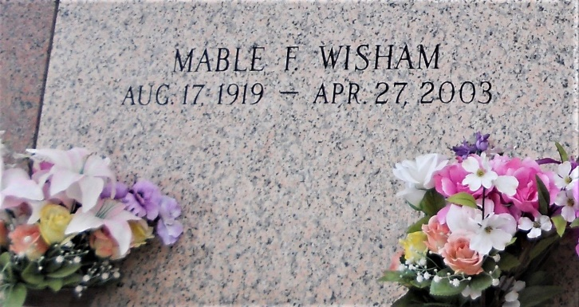

Photo by Team T-Lo

Mable 'Dukee' Wisham Departed This Earthly Life And Entered Into Eternal Rest On Sunday, April 27, 2003. Wife Of The Late Rivers Wisham. Beloved Mother Of Eula Mae Green Of Portland, Or., Ralph Wisham Of Reserve, La., Carolyn Mason Of Reserve, La. And Eloise Sanders Of Laplace, La. Sister Of Mildred Gray Of New Orleans, La., Marjorie Bardell Of Mt. Airy, La. The Late Bertha Keys, Beulah Nicholas, Ethel Joseph, Hattie Howard, Edna Ross, Audrey Francois, Ernest, Sr., Earl Sr., James Jr. And Rev. J. J. Farlough, Sr. Sister-In-Law Of Johnny Wisham And Anna Spann Of Garyville, La., 10 Grandchildren, 20 Great-Grandchildren And 20 Great-Great-Grandchildren, Nieces, Nephews, Other Relatives And Friends.

Relatives And Friends Of The Family Also Priests And Parishioners Of Our Lady Of Grace Catholic Church, Employees Shell Chemical, Odyssey Health Care, Brand Scaffold And St. John School Board Are Invited To Attend A Mass Of Christian Burial On Saturday, May 3, 2003 At 11:00 A.M. At Our Lady Of Grace Catholic Church, Reserve, La. Rev. Rodney, Celebrant. Interment In St. John Memorial Gardens, Laplace, La. Visitation Will Be From 9:00 A.M. Until Service. Bardell's Mortuary Of Mt. Airy In Charge. Information 985-535-6837.

The Times-Picayune, New Orleans, Louisiana

May 2, 2003