Ralph Wisham

February 2, 1948 – December 8, 2005

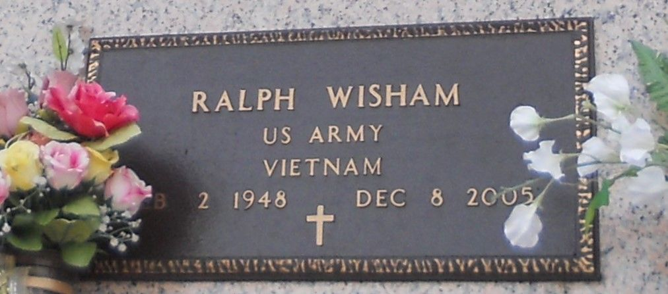

Photo by Team T-Lo

Ralph 'Ralphfee' Wisham Departed This Earthly Life On December 8, 2005 At His Sister's Resident In Houston, Tx. Son Of The Late Mable And River Wisham. Beloved Father Of Merina Dee Wisham Of Reserve, La. Loving Brother Of Carolyn Mason Of Reserve, La, Eloise Sanders Of Houston, Tx, And Eula Mae Green Of Portland, Oregon. Grandfather Of Darius Thomas, Danae And Ja'quan Wilson. Nephew Of Marjorie Bardell Of Mt. Airy, La, Anna Spann And Johnny Wisham Of Garyville, La. Also Survived By Nieces, Nephews Other Relatives And Friends.

Relatives And Friends Of The Family, Also Pastors, Offices And Members Of Mileville Memorial Church Of God In Christ, Our Lady Of Grace Catholic Church, St. Michael Baptist Church, Shell Chemical And All Neighboring Churches Are Invited To Attend The Funeral Services On Saturday, December 17, 2005 At 10:00 Am At The Mileville Memorial Church Of God In Christ, 129 Apple St. Laplace, La. Bishop Ronald Frank Officiating. Interment In St. John Memorial Garden 2205 W. Airline Hwy. Laplace, La. Visitation Will Be At The Above Name Church From 5:00 Pm To 8:00 Pm Friday Night December 16, 2005 And On Saturday From 9:00 Am Until 10:00 Am. Bardell's Mortuary Of Mt. Airy, La In Charge. Information: 985-535-6837.

The Times-Picayune, New Orleans, Louisiana

December 16, 2005