Richard Dale Wolfe
April 11, 1940 – October 27, 2022
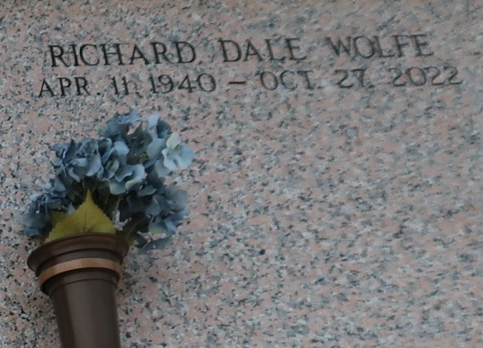

Richard Dale Wolfe, Sr., a lifelong resident of St. John the Baptist Parish, was born on April 11, 1940, to the late Henry P. Wolfe Sr., and Lithia Etienne Wolfe in New Orleans, LA. He was reared in the Catholic religion and attended Our Lady of Grace Roman Catholic Church. He graduated from Fifth Ward High School.
As a young man, he was employed by the U.S. Department of Agriculture, Ecol Petroleum, and Marathon Petroleum. Later in life, after serving his constituents for over three decades, this "man of the people" had the distinction of retiring from both the St. John the Baptist Parish's School Board and Parish Council.
On Thursday, October 27, 2022, at the age of 82, this father, grandfather, great-grandfather, brother, and great-friend to many, peacefully passed away surrounded by his children.
Those left to mourn his presence include his children from his first marriage to June Gray Wolfe: Richard Dale Wolfe Jr. (Eileen), Camille Wolfe Oubre (Anthony), Regina Wolfe Burke (Royal), and Patrice, Kim, and Arnold Wolfe; Terrence, Darren, and Endya Wolfe, the opposing from his second marriage to Melba Crawley Wolfe; and Carlotta Franklin, Keithen Nelson (Rebecca), Ayesha D. Collins, Aaron Dale Johnson Sr., and Juan Alexander; his only brother: Rev. Henry Wolfe Jr; his trusted and faithful friends: Chuck Savoie, Shondrell P. Campbell, Milton Clofer Sr., Lionel Bailey, Eric Bourgeois, Oscar Lawrence, Larry Sorapuru, Charles Julien, and Demond Lee; and a host of grandchildren, great-grandchildren, nieces, nephews, relatives, and friends.
He was preceded in death by his parents: Henry P. Wolfe Sr., and Lithia Etienne Wolfe; sister: Gwendolyn Wolfe Hall; and son: Kenthen Nelson.
Relatives and friends are invited to attend a public visitation on Friday, November 11, 2022, from 6 pm-9 pm at Our Lady of Grace Catholic Church, 772 LA-44, Reserve, LA 70084. A Mass of Christian Burial will be held at Our Lady of Grace Catholic Church, 772 La-44, Reserve, LA 70084 on Saturday, November 12, 2022, celebrated by Father Godwin Ani S.S.J. Visitation from 8:15 am until 10:00 am. Mass will begin at 10:00 am. Recitation of the Holy Rosary at 8:45 am. Interment will follow at St. John Memorial Gardens, 2205 W Airline Hwy, Laplace, La 70068.

Treasures of Life Center for Funerals, Gramercy, Louisiana

