Walter E. Wood Sr.

April 20, 1913 – February 7, 2000

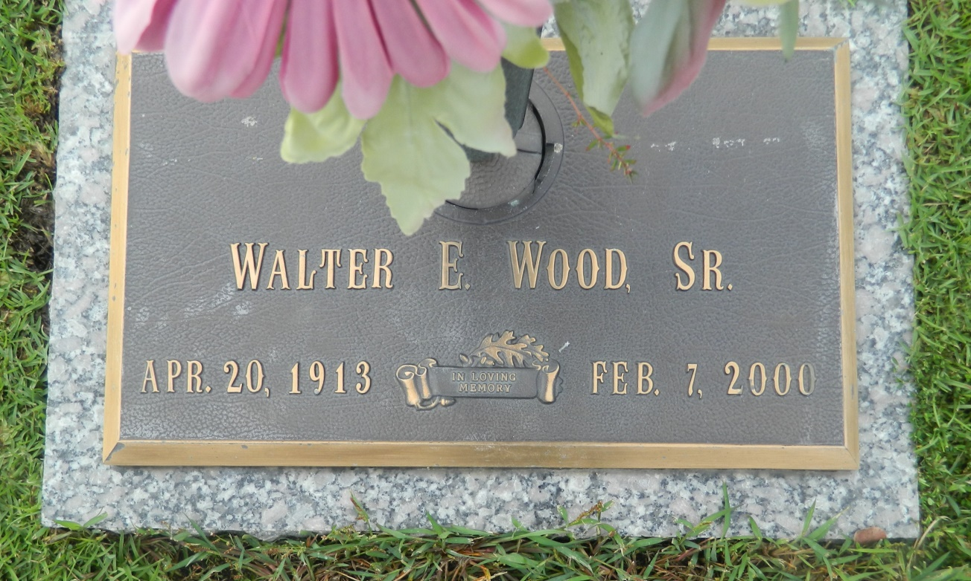

LAPLACE Walter E. Wood Sr., 86, a native of Telico, Texas, and a resident of Garyville, died Feb. 7. He was the husband of the late Ruth Wood and father of Anita Saucier and the late Walter Wood Jr.  
  
He is also survived by two grandchildren and three great-grandchildren.  
  
Graveside services are today at 2 p.m. at St. John Memorial Gardens, LaPlace.

L'Observateur (La Place, LA) - Wednesday, February 9, 2000

Contributed by Jane Edson